**Learning Objective**

We are learning how to solve a natural world problem by using and applying our skills and knowledge of measurement, weight and mass.

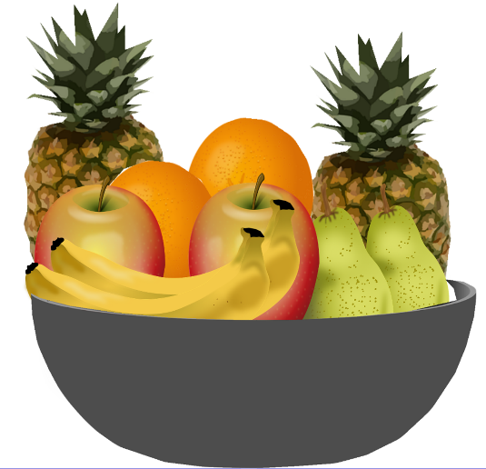**The Problem:**

Here is a picture of a bowl of fruit. The total weight of all the fruit in the bowl is **3 kg.**

The scales below show how much the different fruit in the bowl weigh.

**Can you calculate the weight of a single orange?**

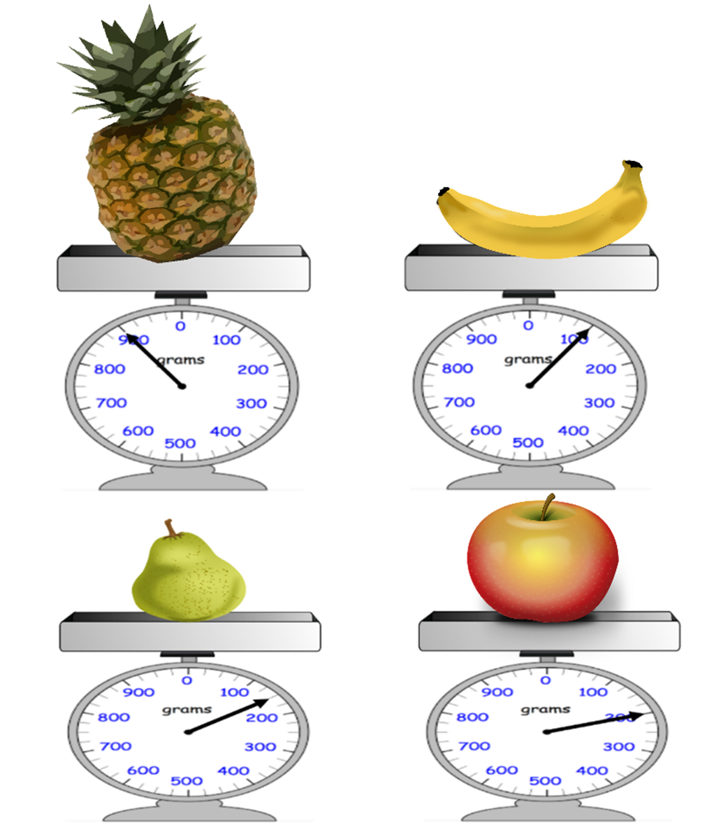**Recording:**

*Use this space to show your working out.*

**Answer:** A single orange weighs _______________ .