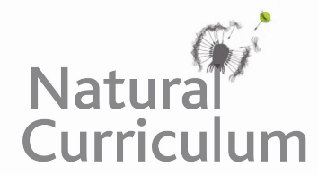**Learning Objective**

We are learning how to solve a natural world problem by using and applying our skills and knowledge of measurement, weight and mass.

**The Problem:**

One Summer’s evening, a female sparrowhawk caught and ate 3 sparrows. That same day, each sparrow had eaten 20 cabbage white caterpillars. Between them, the cabbage white caterpillars had eaten 2 whole cabbages from Professor Greenfinger’s vegetable patch.

**Using the food chain mass information (see below), can you calculate the total mass of all the plants and animals described above?**

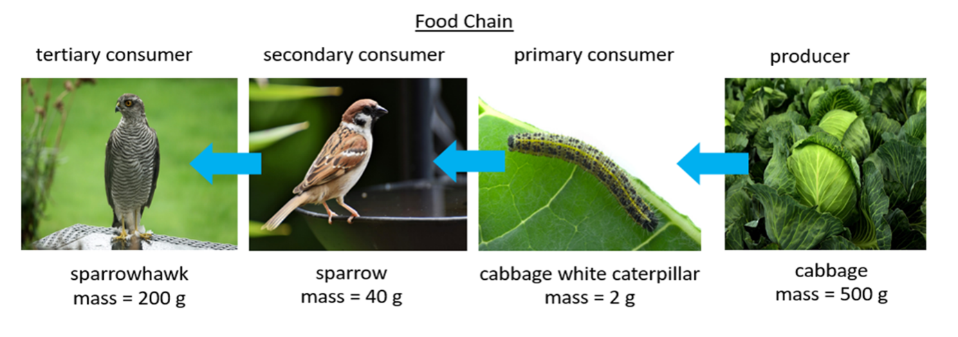**How will you make sure that you don’t miss out any plants or animals from your calculation?**

**Recording**

*Use this space to show your working out.*

**Answer:** The total mass of all the plants and animals is _________________ .