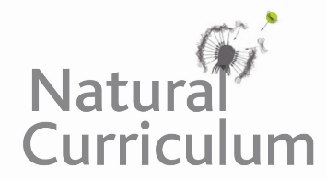**Learning Objective**

We are learning how to solve a natural world problem by using and applying our skills and knowledge of moneyand pounds and pence.

**The Problem:**

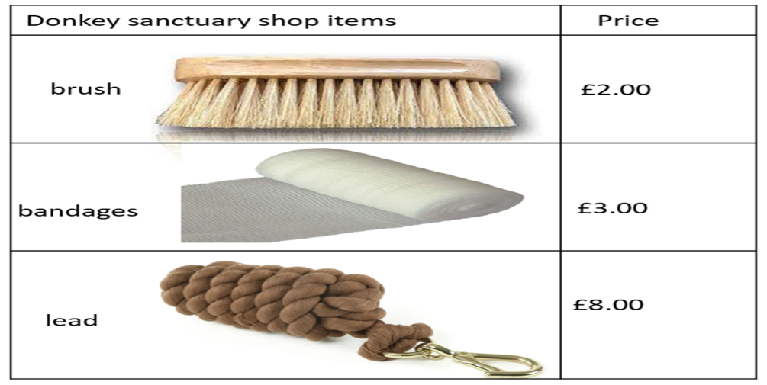Dora visited her local donkey sanctuary every weekend to see the donkey that she had adopted. Her donkey was called Martha. At the sanctuary, visitors could buy items for their adopted donkey in a small shop. The items (shown opposite) included bandages for wounds, brushes for grooming and leads for exercising.

One weekend, Dora decided to buy some **bandages** for Martha. She paid for the bandages using **7 coins**. She did not receive any change.

**Which coins did Dora use to pay for the bandages? Is there more than one answer? How do you know?**

**Recording:**

*Use this space to show your working out and solutions.*

