**Learning Objective**

We are learning how to solve a natural world problem by using and applying our skills and knowledge of numberand fractions.

**The Problem:**

Using the picture, your knowledge of fractions and a fraction wall, can you sort the cards into two piles to show which cards are true and which cards are false?

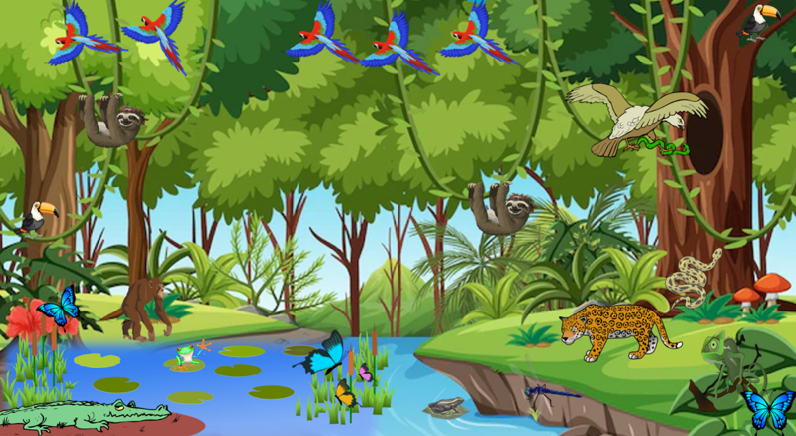

Fraction Wall

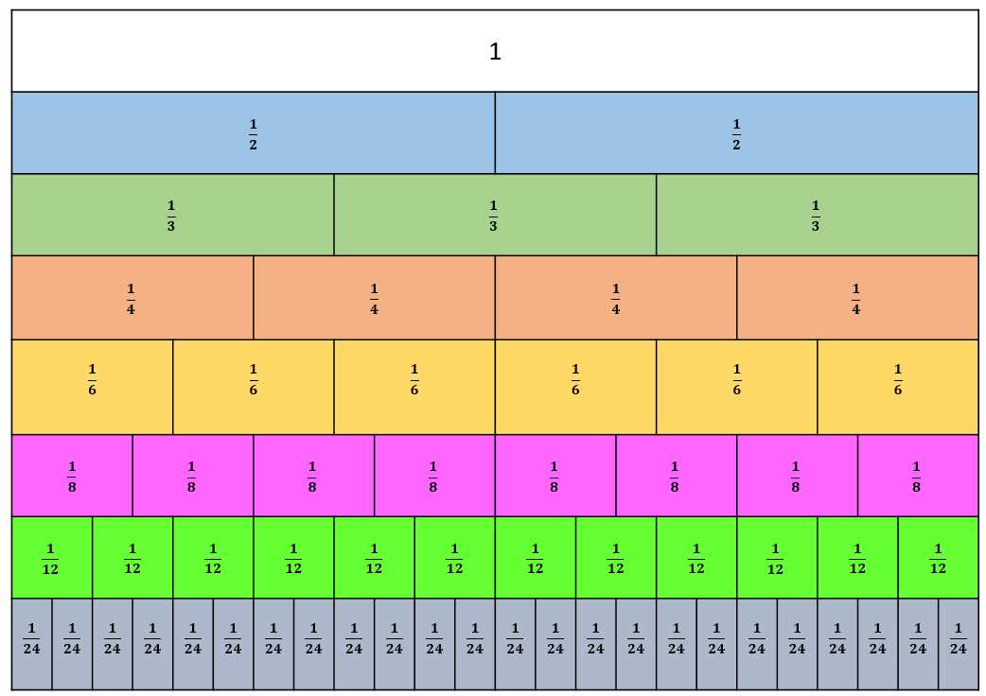



*Cut out the cards and sort according to whether they are true or false.*

