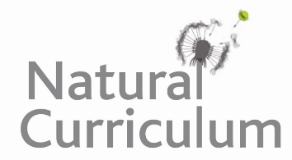**Learning Objective**

We are learning how to solve a natural world problem by using and applying our skills and knowledge of measurement and money (£ and p)

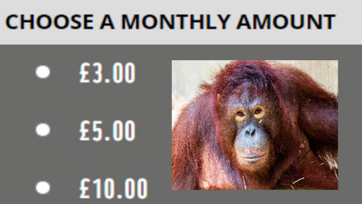**The Problem:**

The amounts of money that you can give an animal charity each month to ‘virtually’ adopt an orangutan are shown in the table opposite**.**

Class 3M decided to have a book sale so that they could raise enough money for the charity and adopt an orangutan for **one year**.  All of the money that the class raised in the book sale is shown below.

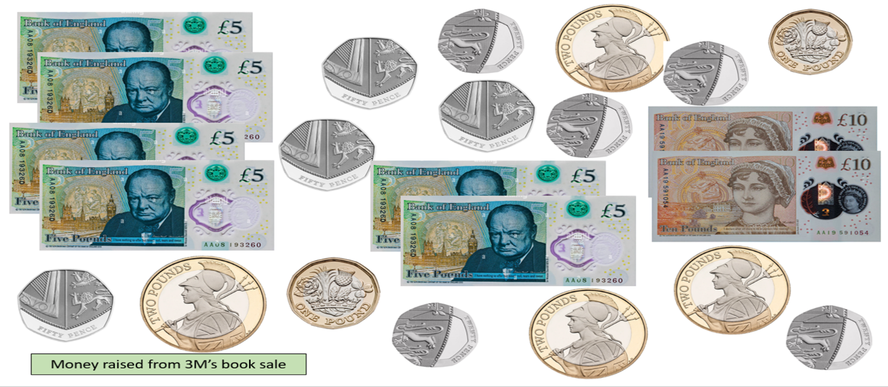**Which of the 3 monthly amounts (£3, £5 or £10) did class 3M choose?**

**Recording:**

*Use this space to show your working out.*

**Answer:**

I think Class 3M chose the ______________ monthly amount.