**Learning Objective**

We are learning how to solve a natural world problem by using and applying our skills and knowledge of length and perimeter.

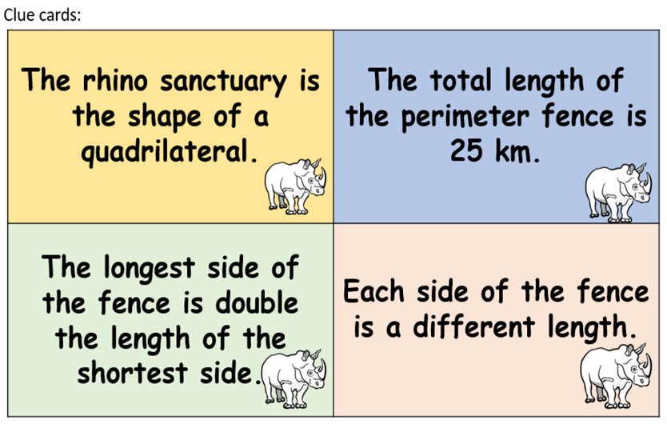**The Problem:**

A new rhino sanctuary has just been built for two rhinos. Their names are Ipuh and Laksari. Inside the sanctuary, they will be able to forage for food and wallow in mud baths. They will be safe from poachers due to an electrified perimeter fence that runs all the way around the sanctuary.

**Using the clue cards (above), can you calculate the length of each side of the perimeter fence?**

**Recording/Solutions:**

Use this space to show what you think the sanctuary might look like and the lengths of each side of the perimeter fence.

**Is there more than one solution to this problem? How do you know?**