**Learning Objective**

We are learning how to solve a natural world problem by using and applying our skills and knowledge of numberand fractions.

###

**The Problem:**

One sunny day, two caterpillars (Terry and Larry) spent the morning, afternoon and evening eating identical leaves that belonged to a shape tree. The fractions of each leaf eaten by the caterpillars are recorded in the tables below the picture.

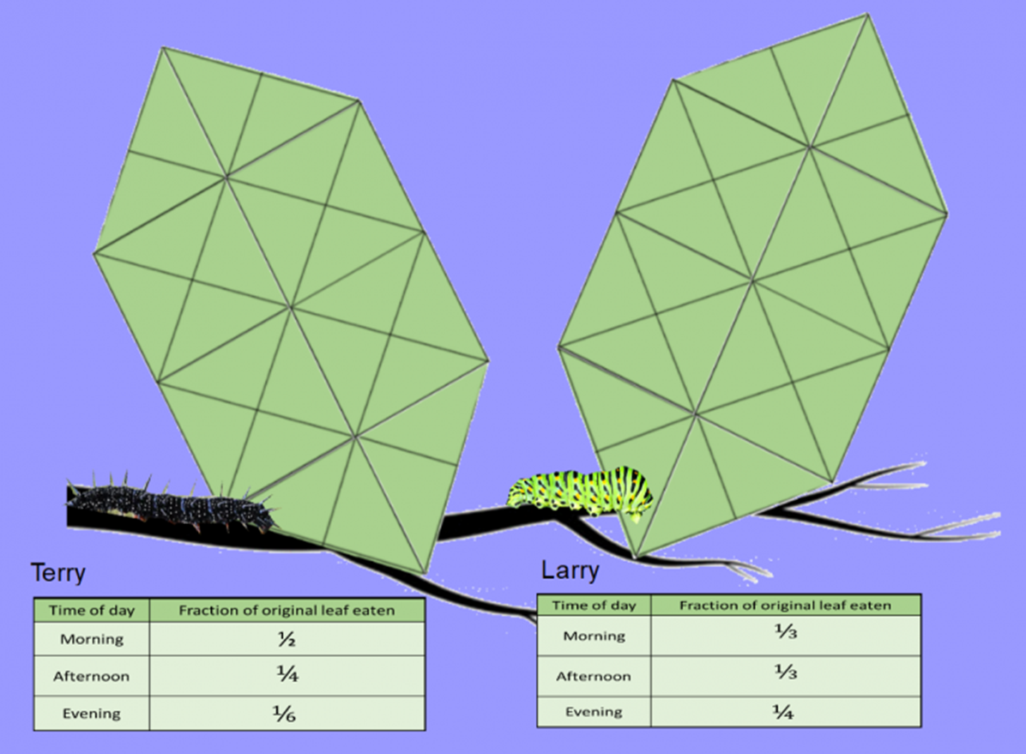**Which caterpillar ate the most?**

**Recording:**

*Use this space to show your working out.*

**Answer:** The caterpillar that ate the most was __________________ .