**Learning Objective**

We are learning how to solve a natural world problem by using and applying our skills and knowledge of moneyand pounds and pence.

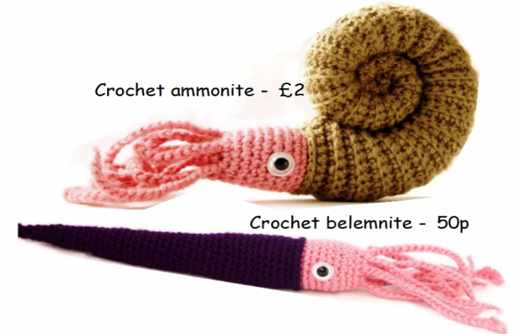**The Problem:**

Molly and Zachary decided to make and sell some crochet ammonites and belemnites. They agreed to sell each ammonite for £2 and each belemnite for 50p.

**If Molly and Zachary raised £15 from the sale of their crochet fossils, how many belemnites and how many ammonites did they sell?**

**There is more than one answer. How do you know if you have found all possible solutions?**

**Recording:**

|  |  |  |
| --- | --- | --- |
|  | Addition of ammonites and belemnites  e.g. £2 + £2 + £2 + £2 + £2 + £2 + £2 + 50p + 50p = £15 | Number of fossils |
| Answer 1 |  | ammonites _______  belemnites _______ |
| Answer 2 |  | ammonites _______  belemnites _______ |
| Answer 3 |  |  |
|  |  |  |
|  |  |  |

You can either use the table below to help you record the number of ammonites and belemnites sold or you can choose your own method of recording.