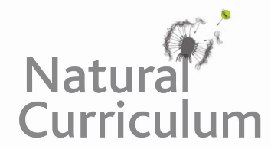**Learning Objective**

We are learning how to solve a natural world problem by using and applying our skills and knowledge of geometry and 3-D shape.

**The Problem:**

**With a partner, can you match the clue card descriptions with the correct crystal type image?**

**Which crystal type does not have a description? What might this description be?**

Carefully cut out the crstal type images and clue card descriptions.

