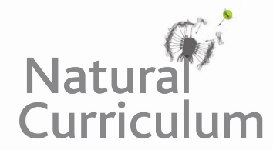**Learning Objective**

We are learning how to solve a natural world problem by using and applying our skills and knowledge of geometry and 2-D shape.

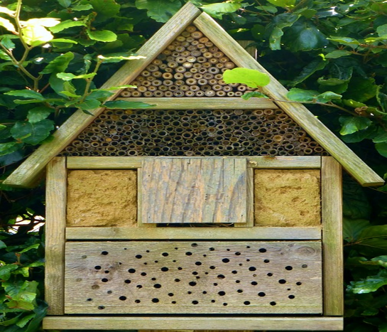**The Problem:**

.**If you were asked to design a bee hotel that had a face with the number of shapes listed below, what might it look like?**

* 3  triangles
* 4 rectangles
* 2 pentagons

**Recording:**

Design your bee hotel by joining the dots that are on the square dotty grid below. (**Note:** There must be no spaces between the shapes and the whole of the grid must be used.) **Top Tip**: Draw your bee hotel on a whiteboard first.

