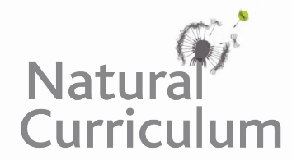**Learning Objective**

We are learning how to solve a natural world problem by using and applying our skills and knowledge of geometry and angles.

**The Problem:**

**How many right angles, obtuse angles and acute angles can you find in Charlotte’s name?**

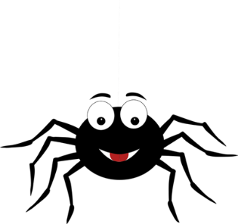

**Recording:**

Record the number of each angle type in this space.

**Further Challenge:**

**Look at the letters in your own name. How many acute angles, obtuse angles and right angles can you find?**