**Learning Objective**

We are learning how to solve a natural world problem by using and applying our skills and knowledge of number and place value.

**The Problem:**

The map opposite shows the location of four fairy rings in a farmer’s field. Altogether there were 50 mushrooms growing in this field.

**Can you use the clues to draw the correct number of mushrooms in each of the five fairy rings?**

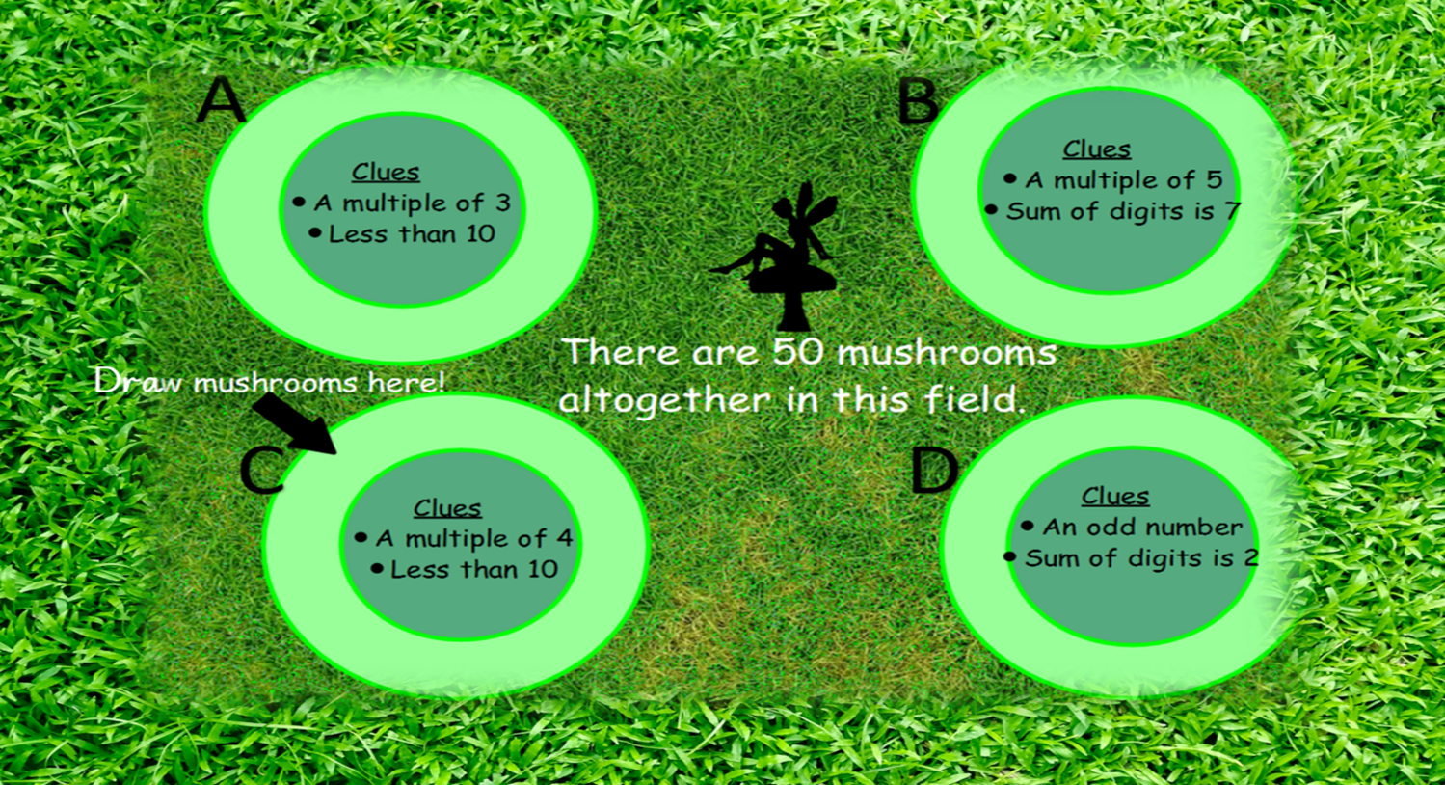

**Recording:**

*Use this space to show your working out.*

**Answer: Fairy ring A = ____________ mushrooms**

**Fairy ring B = ____________ mushrooms**

**Fairy ring C = ____________ mushrooms**

**Fairy ring D = ____________ mushrooms**

**Are there any other possible solutions? How do you know?**