**Learning Objective**

We are learning how to solve a natural world problem by using and applying our skills and knowledge of numberand identifying patterns.

**The Problem:**

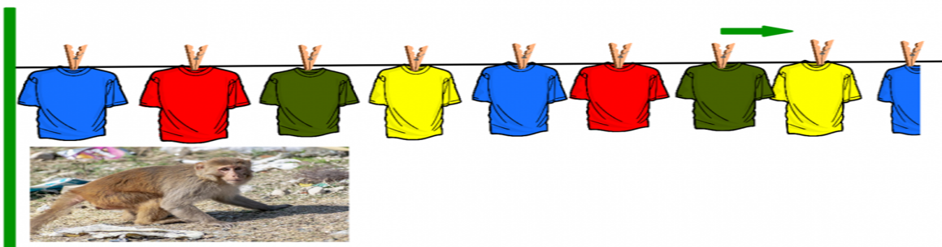In the city Jaipur, there was a very long washing line. Pegged to this washing line, were Mr Sharma’s shirts. All of the shirts on the line were either red, yellow, green or blue. There were **76** shirts in total. Mr Sharma was quite fussy about the order by which they were pegged to the line. You can see this order (from left to right) and the start of the washing line in the picture below.

One afternoon, a mischievous rhesus macaque, called Hanu, stole the **68th** shirt on the line.

**Can you work out the colour of the shirt that Hanu stole?**

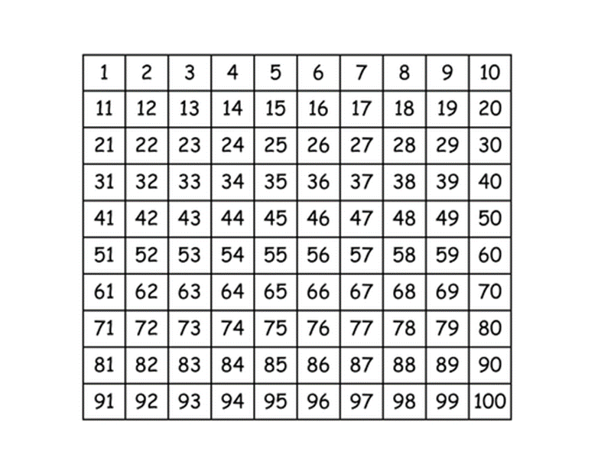**Recording:**

You might find this 100 square helpful.

**Answer:**

The colour of the shirt that Hanu stole was ___________________ .

**Further Challenges:**

How many yellow shirts did Mr Sharma peg to his washing line?