**Learning Objective**

We are learning how to solve a natural world problem by using and applying our skills and knowledge of numberand identifying patterns.

**The Problem:**

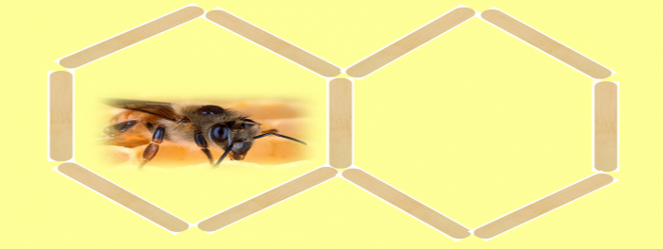Mr Buzalot was a beekeeper. He was also a keen mathematician. Fascinated by the honeycombs that were inside his beehives and their repeating hexagonal forms, he decided to copy their pattern using lollipop sticks. After making 2 hexagons side by side, he noticed how one side was shared (see below).

**Can you help Mr Buzalot answer the questions below?**

1. What is the greatest number of lollipop sticks that would be needed to make**6** hexagons with one or more shared sides?

*(Use this space to draw the hexagons and/or show your solution.)*

Answer: ______________

1. What is the smallest number of lollipop sticks that would be needed to make **6** hexagons with one or more shared sides?

*(Use this space to draw the hexagons and/or show your solution.)*

Answer: _____________