**Learning Objective**

**We are learning how to solve problems that involve finding unit fractions (halves, thirds, quarters, fifths and sixths) of a set of objects.**

**Challenge 1**

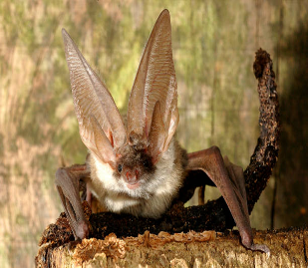**Draw counters in the bars below to solve the following problems.**

1) 18 long-eared bats were roosting in the roof of a church. $\frac{1}{3}$ of the bats were male.

**How many male long-eared bats were roosting in the roof of the church?**

|  |  |  |
| --- | --- | --- |
|  |  |  |

Answer: ______________

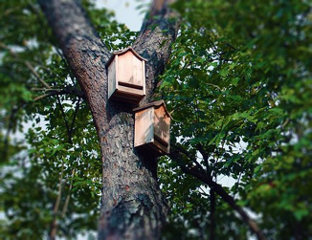

2) In an area of the New Forest, 12 bat boxes were attached to the trunks of trees. $\frac{1}{4}$ of the boxes had common pipistrelle bats roosting in them.

**How many bat boxes had common pipistrelle bats roosting in them?**

|  |  |  |  |
| --- | --- | --- | --- |
|  |  |  |  |

Answer: ______________

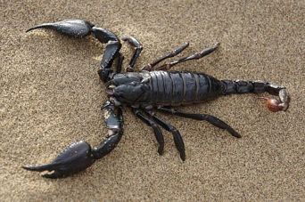3) One night, a pallid bat ate 18 invertebrates that were crawling around on the desert floor. $\frac{1}{6}$ of these invertebrates were scorpions.

**How many scorpions did the pallid bat eat that night?**

|  |  |  |  |  |  |
| --- | --- | --- | --- | --- | --- |
|  |  |  |  |  |  |

Answer: ______________

**Challenge 2**

**Solve the following problems by dividing the bars and drawing counters.**

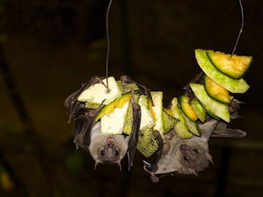

4) In the heart of a rainforest, a large fruit bat fed on the fruit of several different plants. In one week it ate 15 different pieces of fruit.

$\frac{1}{5}$ of the pieces of fruit were bananas.

**How many pieces of fruit were not bananas?**

Answer:

|  |
| --- |
|  |

5) A farmer collected 16 bags of bat poo (guano) from a cave. He kept. $\frac{1}{4}$ of the bags for himself and sold the rest to gardeners who wanted to use the poo to help their plants grow.

**How many bags of bat poo did the farmer sell?**

|  |
| --- |
|  |

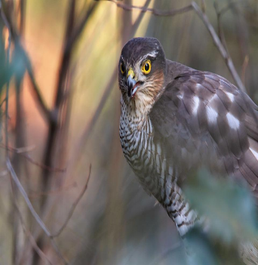Answer: ____________

6) One morning, a bat expert discovered the remains of 2 pipistrelle bats close to his home. They had been killed by a sparrowhawk. This was $\frac{1}{6}$ of the total number of pipistrelle bats that the sparrowhawk had killed during the

month of July.

**What was the total number of pipistrelle bats killed by the sparrowhawk during the month of July?**

|  |
| --- |
|  |

Answer: _____________

**Challenge 3**

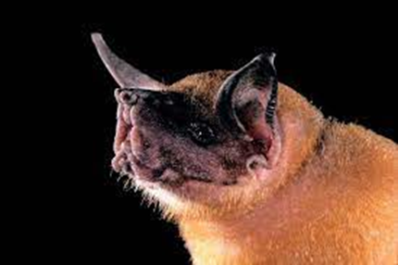A greater bulldog bat used echolocation to catch fish from a Mexican river. It caught a total of 36 fish in a single night. $\frac{1}{6}$ of the fish that it caught were less than 2 cm in length. The remaining fish that it caught were all more than 2 cm in length.

$\frac{1}{5}$ of the fish that were more than 2 cm long were female and the rest were male.

**How many male fish that were more than 2 cm long did the greater bulldog catch?**

*Use this space to show your working out.*

Answer: