**Learning Objective**

**We are learning how to solve problems that involve finding unit fractions (halves, thirds, quarters, fifths) of a set of objects.**

**Challenge 1**

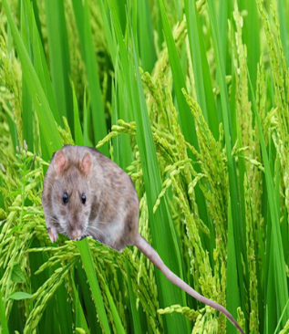**Draw counters in the bar models below to solve the following problems.**

1) A group of 10 smooth-coated otters were hunting rats in a rice field. $\frac{1}{2}$ of the otters in the group managed to catch a rat. **How many otters caught a rat?**

|  |  |
| --- | --- |
|  |  |

Answer: ______________

2) A fisherman trained a smooth-coated otter to chase fish into his net. The otter caught a total of 10 fish. The fisherman gave the otter $\frac{1}{5}$ of the fish that it caught.

**How many fish was the otter given?**

|  |  |  |  |  |
| --- | --- | --- | --- | --- |
|  |  |  |  |  |

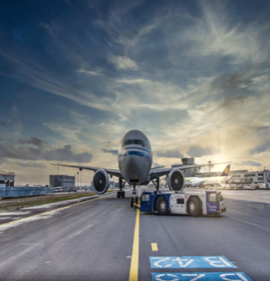

Answer: ______________

3) Sadly, 16 otter pups were discovered in a bag at an airport. They were going to be sold as pets. $\frac{1}{4}$ of the pups were less than 3 months old.

**How many pups were less than 3 months old?**

|  |  |  |  |
| --- | --- | --- | --- |
|  |  |  |  |

Answer: ______________

**Challenge 2**

**Solve the following problems by dividing the bars and drawing counters.**

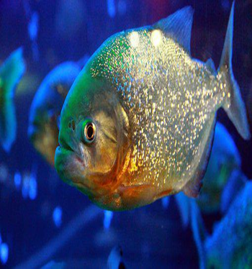4) A family of giant otters caught a total of 18 fish in the Amazon River.

$\frac{1}{3}$ of the fish were piranhas.

**How many fish did the giant otter family catch that weren’t piranhas?**

|  |
| --- |
|  |

Answer: ______________

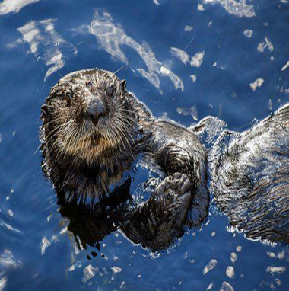5) A sea otter mother swam 30 metres underwater before coming to the surface for air. Her pup only managed to swim $\frac{1}{5}$ of this distance underwater.

**How many metres further than the pup did the mother otter swim underwater?**

|  |
| --- |
|  |

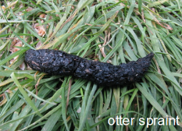Answer: ____________

7) One morning, an otter expert found 12 otter spraints (otter droppings that often contain fish bones and scales) on the bank of a river. This was $\frac{1}{4}$ of the total number of otter spraints that the otter expert found that day.

**How many otter spraints did the otter expert find?**

|  |
| --- |
|  |

Answer: _____________

**Challenge 3**

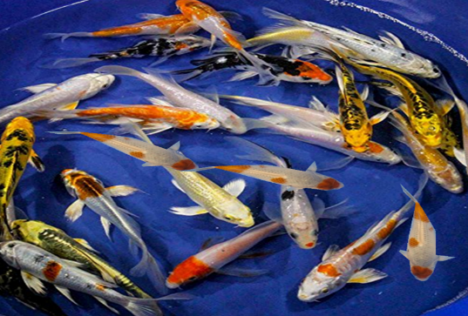In Singapore, a family of smooth-coated otters discovered a pond that had 25 koi carp fish swimming around in it.

The mother otter (sow) dived in first and ate $\frac{1}{5}$ of the koi carp that were in the pond.

The father otter (boar) dived in next and ate $\frac{1}{4}$ of the fish that remained in the pond.

Finally, the eldest pup dived in and ate 5 fish.

**How many fish were left in the pond?** Answer: ____________

**Use this space to show your working out.**