**Learning Objective**

* We are learning how to present and interpret data in a pictogram.
* We are learning how to solve 1 step and 2 step questions using information presented in a pictogram.

**Challenge 1**

**This pictogram shows the numbers of acorns that a squirrel buried over the course of a week.**

|  |  |
| --- | --- |
| **Day of week** | **Number of acorns** |
| **Monday** |  |
| **Tuesday** |  |
| **Wednesday** |  |
| **Thursday** |  |
| **Friday** |  |
| **Saturday** |  |
| **Sunday** |  |

Key

= 5 acorns



1) How many acorns did the squirrel bury on Monday **Answer:** ______________

2) How many more acorns did the squirrel bury on Monday than on Thursday?

**Answer:** ______________

3) How many acorns did the squirrel bury at the weekend?

**Answer: ______________**

Hazel said, **“Over the course of the week, the squirrel buried a total of 24 nuts.”**

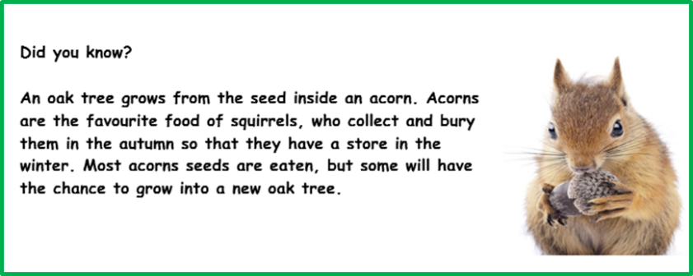4) Can you explain the mistake that Hazel made?

______________________________________

______________________________________

______________________________________

______________________________________

**Challenge 2**

**This pictogram shows the number of seeds and where they landed after falling from a sycamore tree over a period of one week.**

|  |  |
| --- | --- |
| **Landing place** | **Number of sycamore seeds** |
| **grass** |  |
| **stream** |  |
| **bush** |  |
| **picnic table** |  |
| **pavement** |  |
| **mud** |  |

Key

= 4 seeds

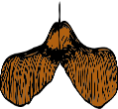

5) How may sycamore seeds fell onto grass? **Answer:** _______________

6) How many sycamore seeds fell onto a bush? **Answer: ________________**

7) How many sycamore seeds fell onto human-made things?

**Answer: ________________**

7) A total of 18 sycamore seeds fell into mud. Complete the pictogram by showing this amount.

8) Over the week-long period, how many seeds fell from the sycamore tree in total?

**Answer:** _______________

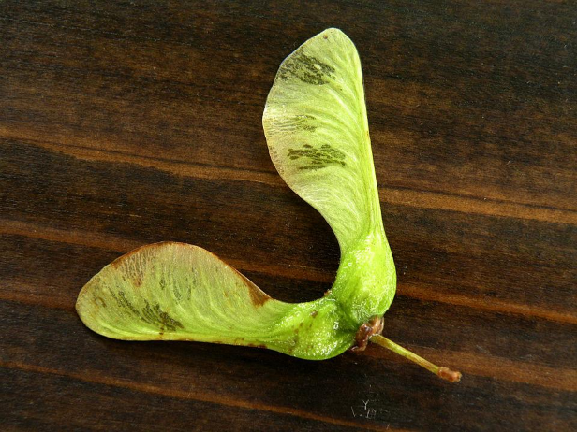**Did you know?**

In the UK, you can find four different trees that have seeds that spiral through the air like helicopters. They are the sycamore, ash, field maple and Norway maple. The papery wings help the seeds travel further away from the parent tree, giving them a better chance of developing into a new tree.

.