
Learning Objective
We are learning how to read, write and represent numbers up to 1,000.

Challenge 1
Represent the numerals (highlighted in bold) in words, counters and base 10 blocks.
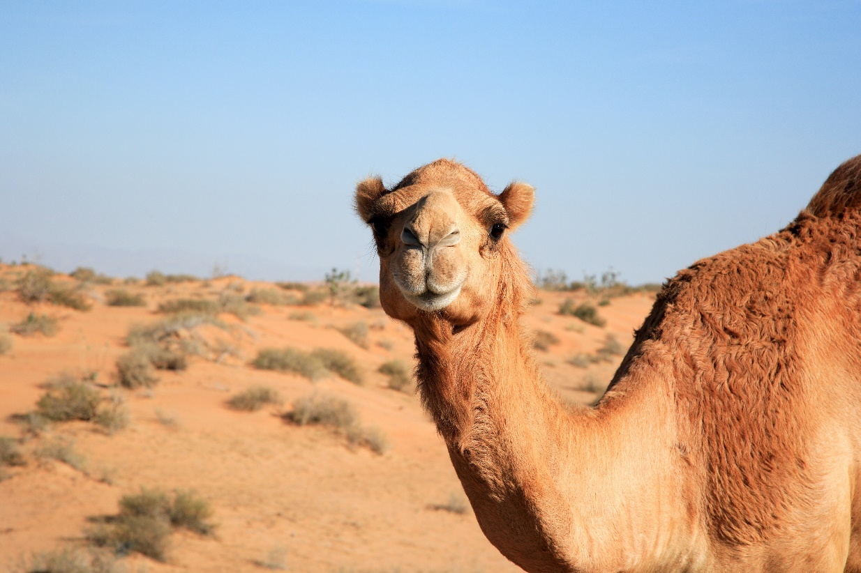
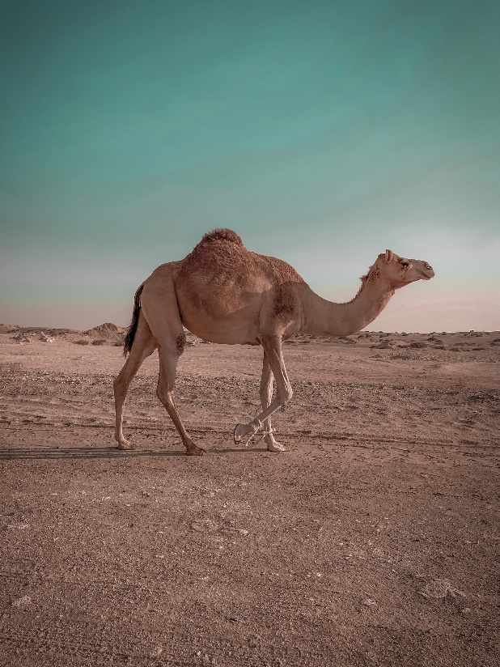  Bactrian camels shed their thick coats in summer when temperatures can reach 120 degrees (Fahrenheit). | Representations |  | A dromedary camel can drink up to 145 litres of water in one drinking session! | Representations
 | Words: |  |  | Words:
 | Counters: |  |  | Counters:
 | Base 10 blocks: |  |  | Base 10 Blocks:
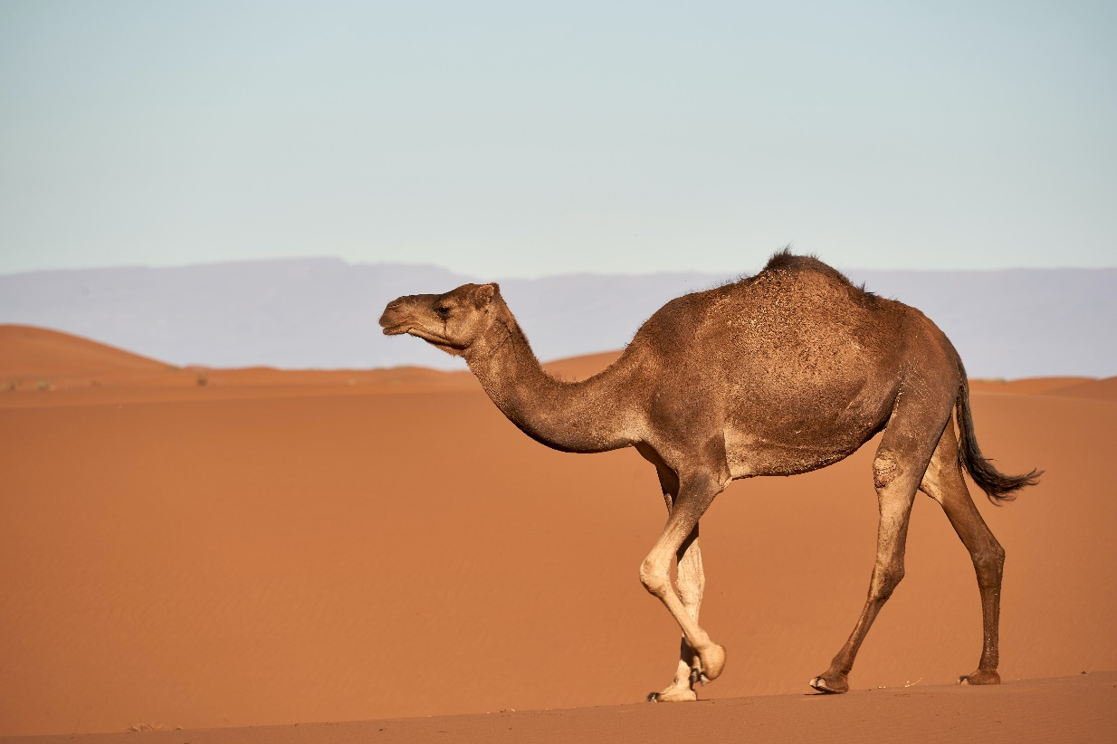
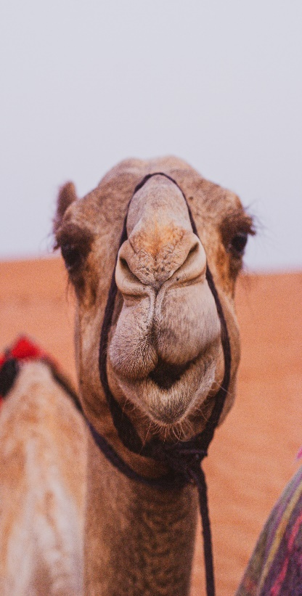
The pregnancy period of a Bactrian camel is around 395 days. | Representations |  | Camels have around 539 bones in their body. | Representations
 | Words: |  |  | Words:
 | Counters: |  |  | Counters:
 | Base 10 blocks: |  |  | Base 10 Blocks:

Challenge 2
Did you know that camels have been crossing the Sahara Desert for thousands of years? In this desert there is a huge sand dune that is 435 metres high.
Leon tried to make 435 using base 10 blocks: | Can you draw the missing pieces of base 10 in the space below?
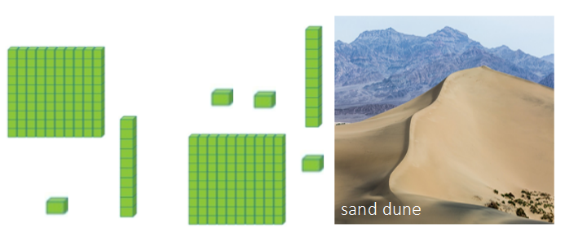

Challenge 3
Here are the total distances that a dromedary camel called Dave travelled in a 4-month period:
Month | Distance travelled (km)
September | 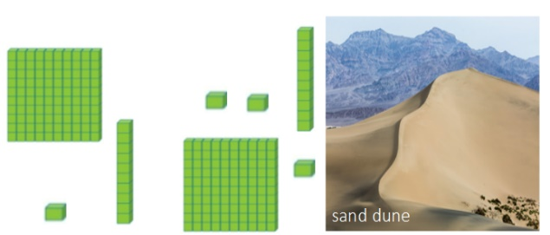
March
June
August | 100  10  1  1  1  10  10  1  100  10  1  100
1) Which month did Dave the camel travel the furthest distance? ______________
2) Which month did Dave the camel travel the shortest distance? _______________
Rupert said, “Dave travelled the same distances in September and June.”
3) Is Rupert right? Yes/No
How do you know? ___________________________________________________
4) What was the total distance travelled by Dave in this 4-month period? _________
Show your working out here:

