**Learning Objective**

We are learning how to read, write, represent, compare and order numbers up to 1,000.

**Challenge 1**

This table shows the number of salmon that four Alaskan brown bears (Oscar, Marvin, Samson and Teddy) ate in a single week.

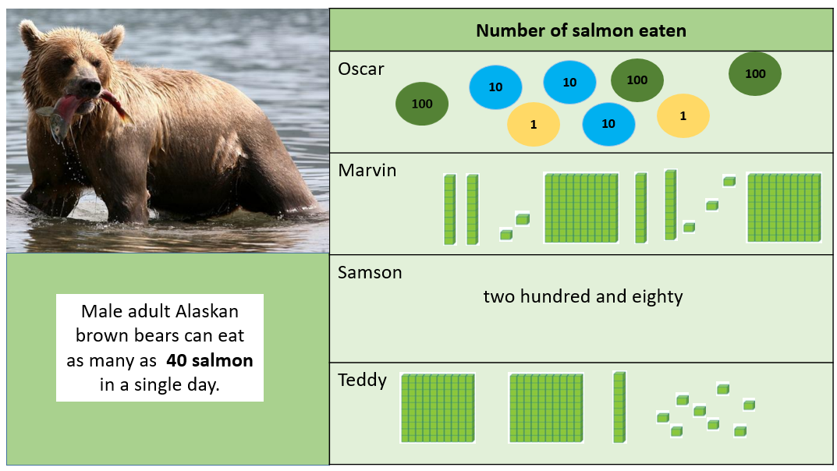

1) Which bear ate the **least** amount of salmon? _____________________

2) Can you order the bears (by name), starting with the one that caught the least amount?

__________ __________ ___________ ___________

Four children (Will, Sandra, Amir and Robin) tried to record the height of a polar bear that was **235 cm** using base 10 blocks.

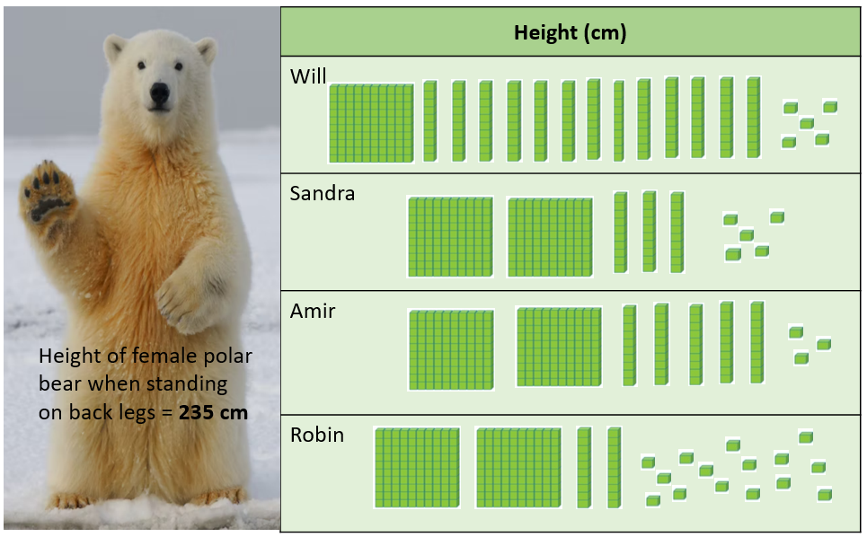

3) Which child did not record the polar bear’s height accurately? ________________

4) Which child showed the polar bear’s height in the best way? _______________

5) Why do you think this? ___________________________________________

_________________________________________________________________

**Challenge 2**

This table shows the number of grizzly bears that were counted in Yellowstone Park in 2006, 2014, 2018 and 2022.

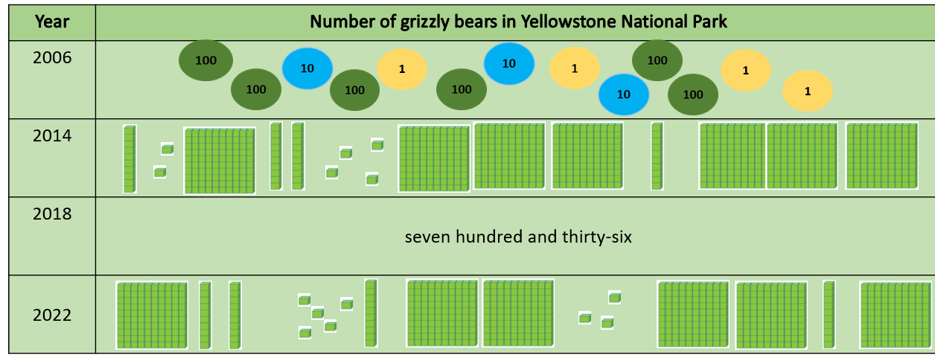

6) Which year had the most grizzly bears in Yellowstone Park? ___________

7) Can you order the years starting with the year that had the **greatest** amount of grizzly bears?

______________ ______________ _______________ _____________

**Challenge 3**

* In Yellowstone, there were **522** more bears in 2022 than there were in 1975.

8) Can you record the amount of grizzly bears in Yellowstone Park in 1975 using **place value counters**?

|  |  |
| --- | --- |
| Year - 1975 | Year - 2022 |
|  |  |

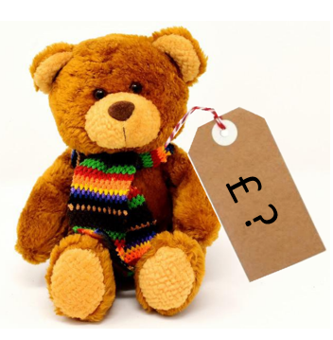9) Can you work out how much it would cost to buy Eric (the rare teddy bear) using the clues below?

- Eric costs more than £500.

- Eric’s price can be made with exactly 8 place value counters.

- The ones digit of Eric’s price is double the tens digit.

Answer: ________________________