**Learning Objective**

We are learning how to read, write, represent and compare numbers up to 1,000.

We are learning how to recognise the place value of each digit in a 3-digit number

**Challenge 1**

Complete the big cat facts by identifying the numbers that are represented in the place value charts.

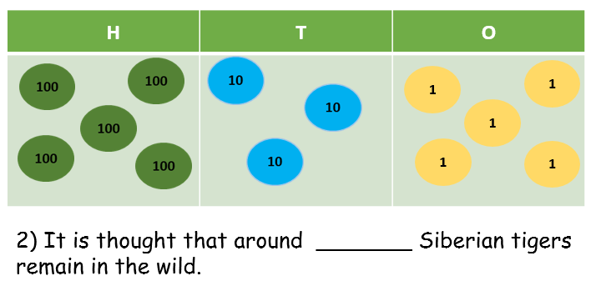 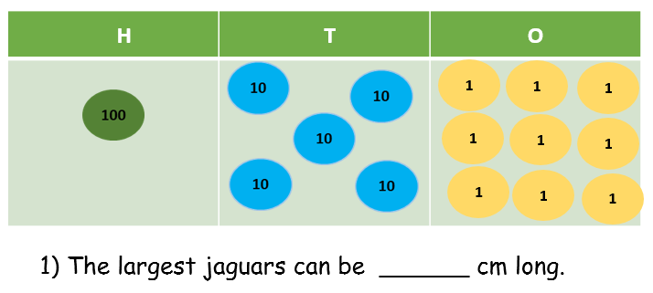

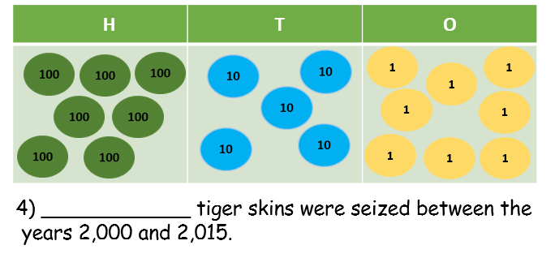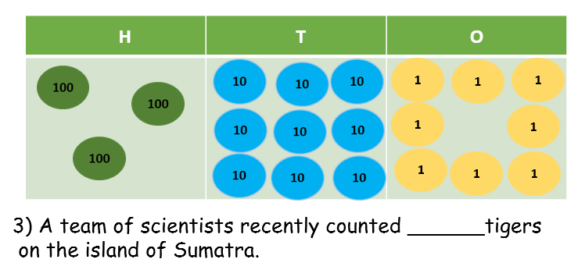

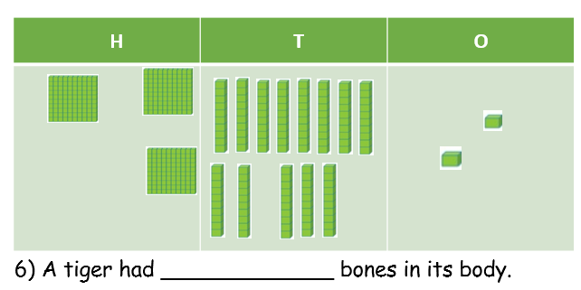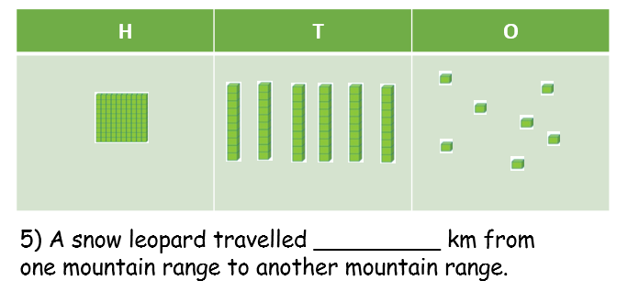

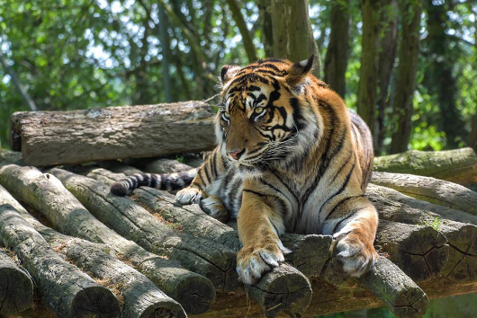**Challenge 2**

Tigers face many threats in the wild. One of the biggest threats comes from **deforestation**. This is when trees (that provide an important habitat for tigers) are chopped down for farming.

The table below shows the number of trees removed from an Indonesian tiger forest in a single week so that **palm oil** plants could be grown.

|  |  |
| --- | --- |
| Monday | 205 |
| Tuesday | two hundred and fifteen |
| Wednesday | 255 |
| Thursday | 198 |
| Friday | 200 + 20 + 5 |
| Saturday | 200 + 10 + 5 |

9) On which day were the fewest trees chopped down? ________________

10) On which two days, where the same number of trees chopped down?

_________________ and __________________

11) How many more trees were chopped down on Wednesday than on Saturday? ___________

*The number of trees chopped down on Sunday was less than 300 but greater than the number of trees chopped down on Wednesday.*

12) Using just **9 counters**, can you show the number of trees that were chopped down on Sunday in the place value chart below?

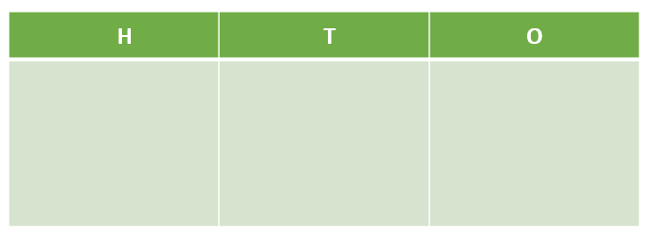

**Challenge 3**

* An Indian tiger called Indira had **between 100 and 130** black stripes.

Sagnik said, “I have made the number of stripes that Indira has using just **5 counters**.”

8) Which 3 numbers could Sagnik have made? _________ , ___________ , ________