**Learning Objective**

**We are learning how to solve problems that involve finding unit fractions (halves, thirds and quarters) of a set of objects.**

**Challenge 1**

**Draw counters in the bar models below to solve the following problems.**

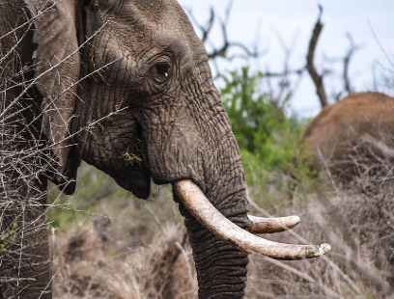1) A herd of 10 elephants were crossing the Zambezi River. $\frac{1}{2}$ of the elephants in the herd had tusks that were more than 1 metre long. **How many elephants had tusks longer than 1 metre?**

|  |  |
| --- | --- |
|  |  |

Answer: ________________

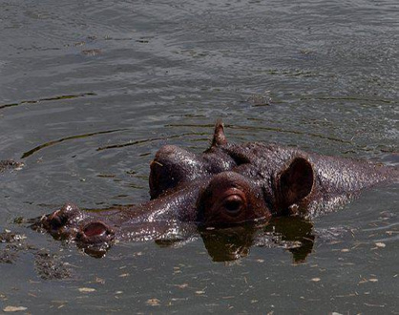2) 12 tourists were staying at a safari lodge close to the Zambezi River. $\frac{1}{3}$ of the tourists went on a day trip and saw hippos cooling off in the river. **How many tourists saw hippos in the river?**

|  |  |  |
| --- | --- | --- |
|  |  |  |

Answer: _________________

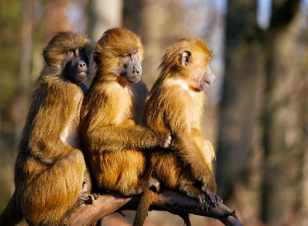3) A troop of 24 baboons were on their way to a mango tree that was outside a safari lodge. $\frac{1}{4}$ of the baboons stopped to have a tickle fight. **How many baboons stopped to have a tickle fight?**

|  |  |  |  |
| --- | --- | --- | --- |
|  |  |  |  |

Answer: ____________

**Challenge 2**

**Solve the following problems by dividing the bars and drawing counters.**

|  |
| --- |
|  |

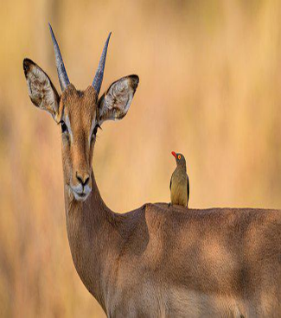4) A small herd of 9 impala tried to cross the Zambezi River. Sadly, $\frac{1}{3}$ of the impala did not make it as they were caught by crocodiles. **How many impala did manage to cross the river?**

Answer: ______________

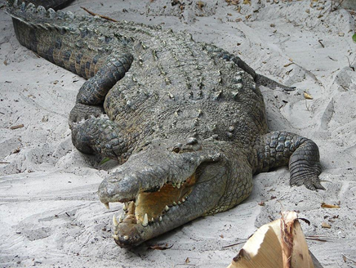5) A boy called Gift travelled to school along the Zambezi River in a canoe. He counted 12 wild animals in total on his journey. $\frac{1}{4}$ of these animals were crocodiles. **How many wild animals did Gift count that weren’t crocodiles?**

|  |
| --- |
|  |

Answer: ____________

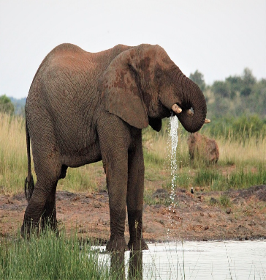7) An African elephant drank 50 litres of water from the Zambezi River. This amount is $\frac{1}{4}$ of the total amount of water that an African elephant can drink in a single day. **How many litres of water can an African elephant drink in a single day?**

|  |
| --- |
|  |

Answer: _____________

**Challenge 3**

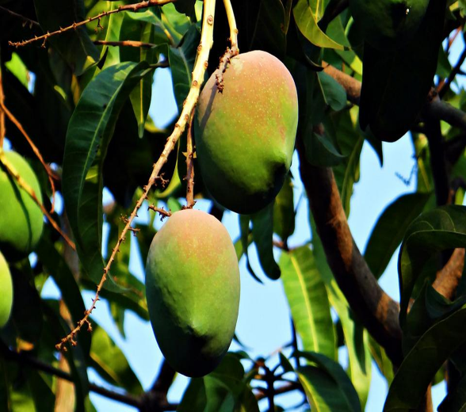6) Outside a safari lodge, there were 24 ripe mangoes on a tree.

In the morning, an elephant ate $\frac{1}{4}$ of the mangoes that were on the tree.

In the afternoon, a baboon ate $\frac{1}{3}$ of the mangoes that were left on the tree.

In the evening , a cook from the lodge removed $\frac{1}{2}$ of the mangoes that remained on the tree for a fruit salad.

**How many mangoes were left on the tree?** Answer: ____________

**Use this space to show your working out.**