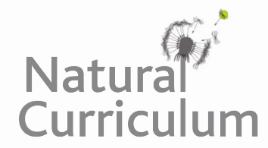**Learning Objective**

* We are learning how to identify reflective and rotational symmetry.

**Challenge 1**

**Look closely at the natural world images below.**

1) Use your ruler to draw where you think lines of symmetry exist.

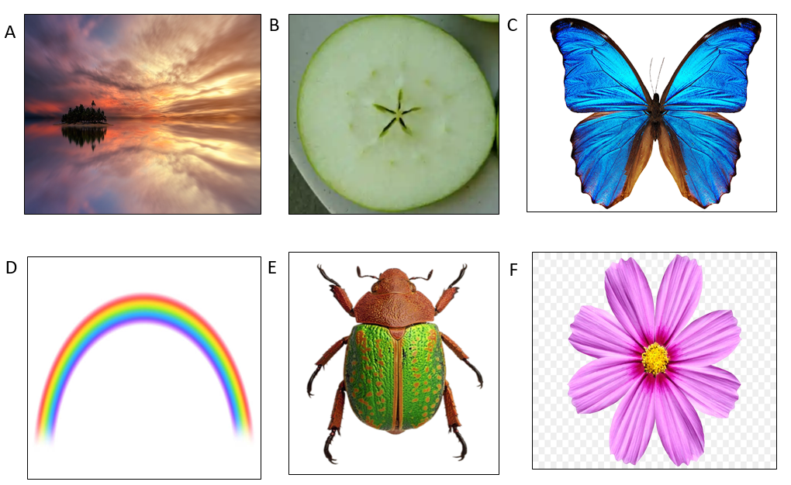

**Challenge 2**

2) Which images have more than one line of symmetry**? Answer:** ________________

3) Which images have rotational symmetry? **Answer:** ________________

4) Can you think of 3 different living things that have symmetry?

__________________ ___________________ ____________________

5) Can you think of 3 different non-living things that have symmetry?

_________________ ____________________ _____________________

**Challenge 3**

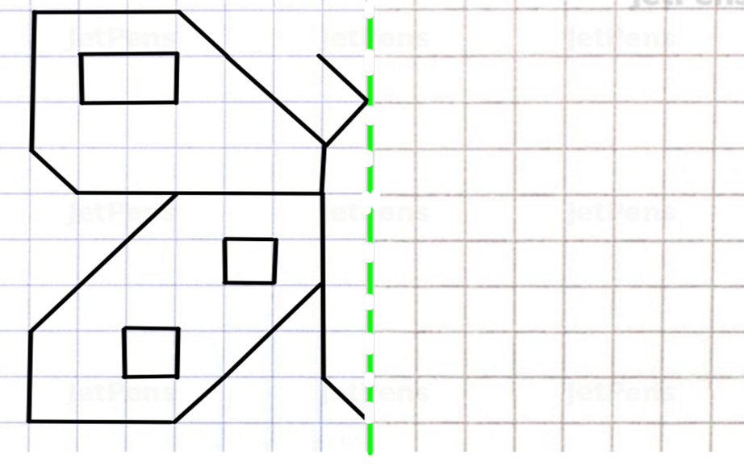**6) Use reflective symmetry to complete the image of the butterfly.**

**7) Add your own symmetrical markings to the wings.**

**8) Colour your butterfly so that its reflective symmetry is kept.**