**Learning Objective**

* We are learning how to present and interpret data in a pictogram.
* We are learning how to solve 1 step and 2 step questions using information presented in a pictogram.

**Challenge 1**

**This pictogram shows the numbers of fossilised shark teeth that were owned by a fossil collector.**

|  |  |
| --- | --- |
| **Type of shark** | **Number of teeth** |
| **megladon** |  |
| **ginsu shark** |  |
| **sand shark** |  |
| **crusher shark** |  |
| **buzzsaw shark** |  |
| **snaggletooth shark** |  |

Key

= 2 teeth



1) How many megladon teeth did the fossil collector have? **Answer:** ______________

2) How many more crusher shark teeth did the fossil collector have than sand shark teeth?

**Answer:** ______________

3) How many megladon, ginsu and sand shark teeth did the collector have in total?

**Answer: ______________**

Robin said, **“The fossil hunter only needs one more shark tooth and he’ll have a total of 20 in his collection.”**

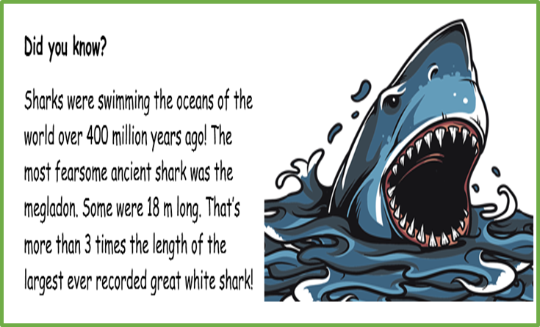

4) Can you explain the mistake that Robin made?

____________________________________

_____________________________________

_____________________________________

_____________________________________

5) The fossil collector also had 24 snaggletooth shark teeth in his collection. Can you show these in the pictogram above?

**Challenge 2**

**The 66 million year old fossilised remains of a triceratops were found in the United States. The pictogram below shows the number of bones that were discovered and the parts of the dinosaur’s body that they were from.**

|  |  |
| --- | --- |
| **Type of bone** | **Number of bones found** |
| **Back** |  |
| **Foot** |  |
| **Leg** |  |
| **Head** |  |
| **Rib** |  |

Key

= 4 bones



6) How many back bones were found? **Answer:** ______________

7) How many feet bones were found? **Answer:** _______________

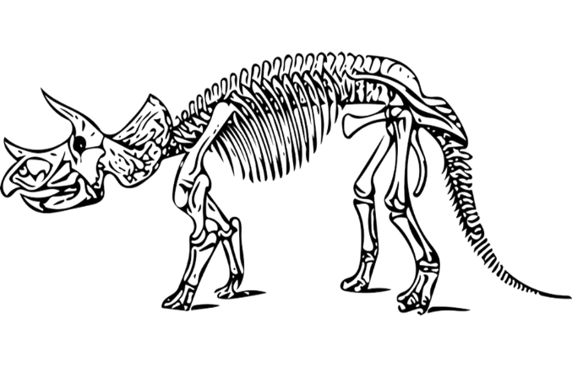**Rayan said, “There were 8 more leg bones found than head bones.”**

3) Can you explain the mistake that Rayan made?

____________________________________

_____________________________________

_____________________________________

_____________________________________

4) A total of 24 rib bones were also discovered. Can you complete the pictogram to show this number?

5) How many fossilised triceratops bones were found altogether? **Answer:** ___________

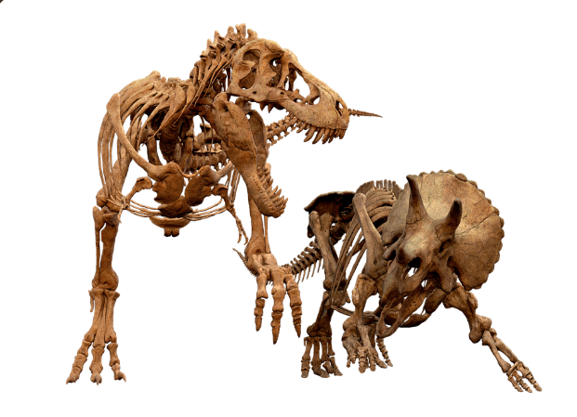**Did you know?**

The horns of triceratops could have been used to fend off attacks from a Tyrannosaurus Rex. A Triceratops fossil was found in in 1997 with a horn that was bitten off. The bite marks matched the razor-sharp teeth of a Tyrannosaurus!

.