**Learning Objective**

We are learning how to multiply by 5.

**Challenge 1**

1) How many common starfish arms are there altogether?

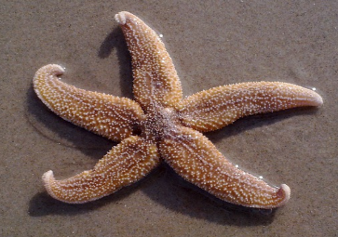

Answer: + + + = Answer: x =

2a) Look at the photograph below. What multiplication does this show?

Answer: x **=**

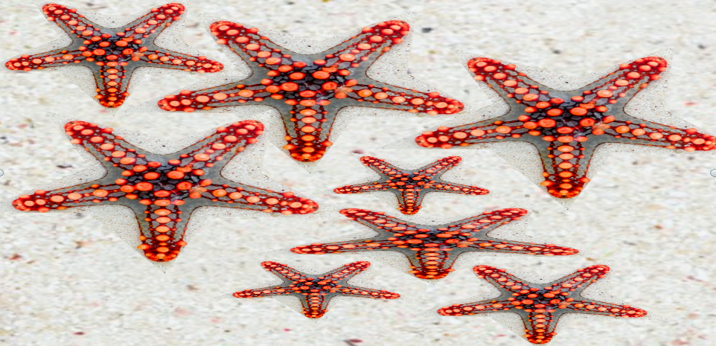

b) Complete the bar model below to represent the number of starfish arms you can see

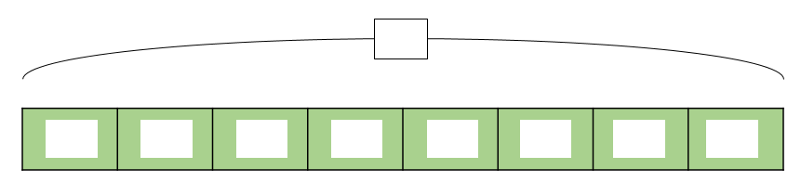 in the photograph above.

3) Can you spot the brittlestars that have missing arms?

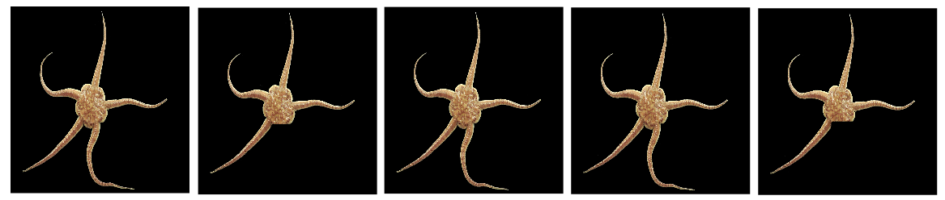

1. How many brittlestar arms can you see altogether? _________ arms
2. Put a tick by the number sentence that represents the total number of brittlestar arms shown above.

3 x 5 + 4 + 4 5 + 5 + 5 + 4 + 4 3 x 4 + 5 +

**Challenge 2**

**Read each word problem carefully and highlight the important information.**

4) On the sea bed, a diver spotted 3 royal starfish, 2 necklace starfish and 3 blue sea star starfish.

**If all of these starfish had five arms, how many arms did the diver spot altogether?**



Answer:

5) Eleven common brittlestars had made their home in a large rock pool. They were all the same age.

**If** **the combined age of the brittlestars was 55 years, how old was each brittlestar?**



Answer:

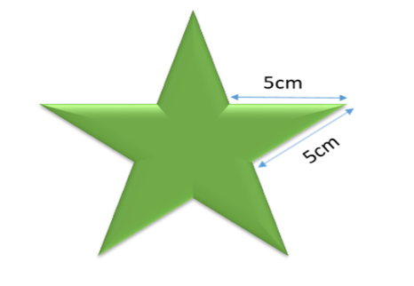6) Look closely at this star shape and the lengths that are marked. **Can you calculate the distance (perimeter) all the way around the shape?**



Answer:

7) There was an **odd** number of five-armed starfish and an **even** number of five-armed brittlestars feeding on the remains of a dead octopus. Altogether, there were 45 arms belonging to this group of starfish and brittlestars.

**a)** **How many brittlestars were there? b) How many starfish were there?**

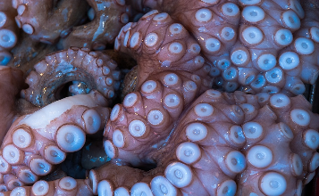

Answer: Answer:

**c) Is there more than one possible answer to this question?** Yes/No

**d) Can you prove it?**

**____________________________________________________________________________________________________________________________________________**

**Challenge 3  
Using your knowledge of the natural world and animals, write your own word problem based on the multiples-of-5 bar below?**

 



