**Learning Objective**

* We are learning how to present and interpret data in a bar chart.
* We are learning how to solve 1 step and 2 step questions using information presented in a bar chart.

**Challenge 1**

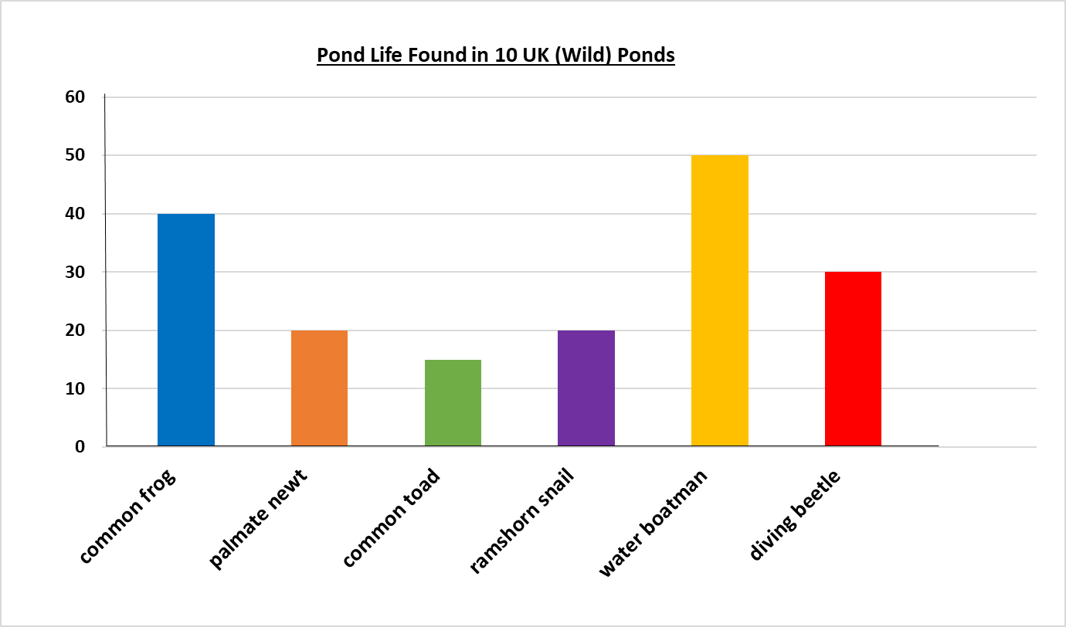**This bar chart shows the number of creatures found in 10 UK wild ponds. Look carefully at the information and answer the questions below.**

1) What was the most common species of pond life? ___________

2) Which species had double the number of palmate newts? ___________

3) What is the difference between the number of:

a) ramshorn snails and diving beetles? _________

b) common toads and water boatmen? _________

“**The combined number of newts, common frogs and water boatmen is less than 100.”**

4) Is the above statement true or false? ___________

5) Explain how you know.

__________________________________________________________________________________________________________________________________________________________________________________________________________________

**Challenge 2**

**This tally chart below shows the different types of fish in a large garden pond.**

|  |  |  |
| --- | --- | --- |
| **fish species** | **Tally** | **Total** |
| **common goldfish** | **~~||||~~ ~~||||~~ ~~||||~~ ~~||||~~ ||** |  |
| **shubunkin** | **~~||||~~ ~~||||~~ ~~||||~~** |  |
| **Koi carp** | **~~||||~~ |||** |  |
| **fathead minnow** | **~~||||~~ ~~||||~~ ~~||||~~ |||** |  |
| **sturgeon** | **~~||||~~ ||** |  |

a) Complete the tally chart.

b) Complete the bar chart to represent the data in the tally chart.

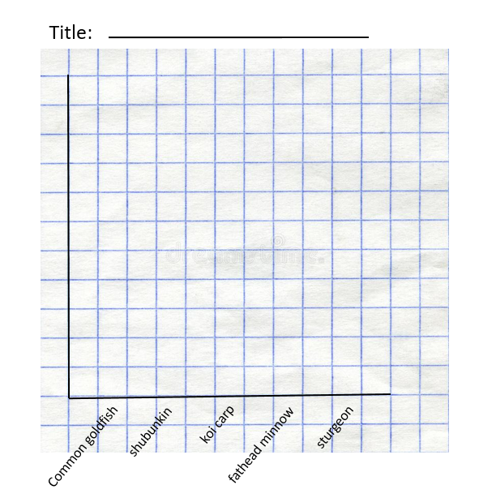

**Challenge 3**

**Use your bar chart to answer the following questions:**

1) Which is the least common species of pond fish? **_________**

2) How many more goldfish than koi carp were in the pond? _________

3) How many shubunkin, koi carp and sturgeon were in the pond altogether? _________

**“The combined number of fathead minnow and sturgeon was 4 less than the combined number of goldfish and koi carp.”**

4) Is this statement true or false? _________

5) Explain how you know.

____________________________________________________________________________________________________________________________________________