**Learning Objective**

We are learning how to multiply by 2.

**Challenge 1**

1) How many human feet can you see altogether?

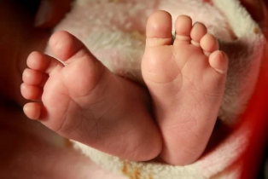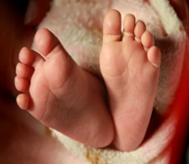

Answer: + + + = Answer: x =

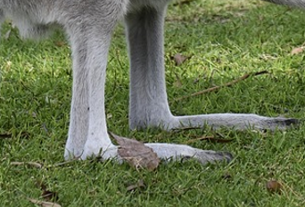2) How many kangaroo legs can you see altogether?



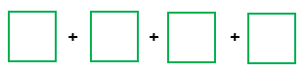

Answer: + + = Answer: x =

3) How many emu eyes can you see altogether?

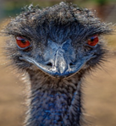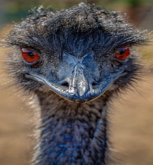



Answer:

+ + =

Answer: x =

**Challenge 2**

**Read each word problem carefully and highlight the important information.**

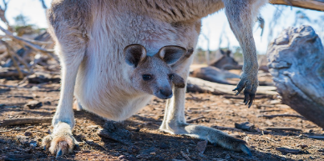4) Three female kangaroos were bounding across the Australian Outback. Each female was carrying a baby (joey) in her pouch.

**How many ears were there altogether in this group of kangaroos?**

Answer:

5) There was a mob (group) of emus. Three of these large birds were stretching out their wings, four were cleaning their feathers and five were eating grass.

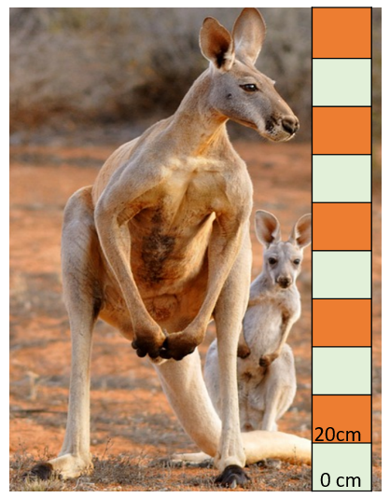 **If** **you could get close enough to this mob of emus, how many emu legs would you be able to count in total?**



Answer:

6) Red kangaroos are the largest kangaroo species. They can jump 9 m in a single bound!

a) How tall is the adult kangaroo in the photograph? ______ m

b) How tall is the joey in the photograph? ______ cm

6) A mixture of kangaroos and emus were grazing in a field. There were 24 eyes in the field. The number of emus was double the amount of kangaroos.

**How many kangaroos were in the field?**



Answer:

**Challenge 3  
Using your knowledge of the natural world and animals, write your own word problem based on the multiples-of-2 bar below?**







