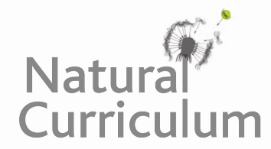**Learning Objective**

* We are learning how to present and interpret data in a bar chart.
* We are learning how to solve 1 step and 2 step questions using information presented in a bar chart.

**Challenge 1**

**The bar chart below shows wingspans of the six different owl species that can be found in the UK. Look carefully at the information and answer the questions below.**

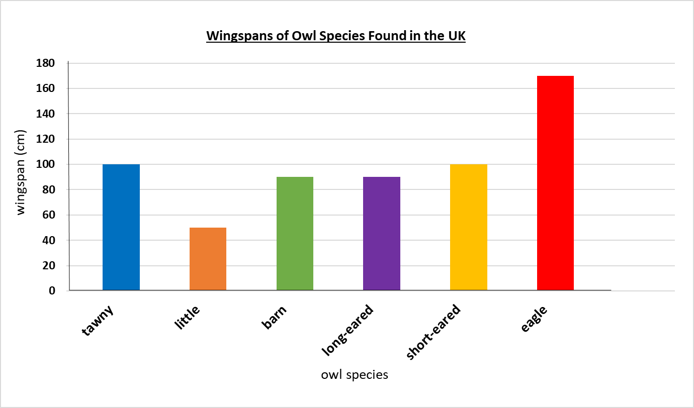

1) How many owl species have a wingspan greater than 1 metre? ___________

2) How many owl species have a wingspan less than 1 metre? ___________

3) How much longer is the wingspan of an eagle owl than a little owl? ___________

“**An eagle owl’s wingspan is over 3 times the length of a little owl’s wingspan.”**

4) Is the above statement true or false? ____________

5) Explain how you know.

______________________________________________________________________

____________________________________________________________________________________________________________________________________________

**Challenge 2**

**This tally chart shows the different types of bones that were found in the pellets of a barn owl.**

|  |  |  |
| --- | --- | --- |
| **Bone types** | **Tally** | **Total** |
| **jaw** | **|||** |  |
| **thigh** | **~~||||~~ |** |  |
| **rib** | **~~||||~~ |||** |  |
| **vertebrae** | **~~||||~~ ~~||||~~** |  |
| **skull** | **||||** |  |

a) Complete the tally chart.

b) Complete the bar chart to represent the data in the tally chart.

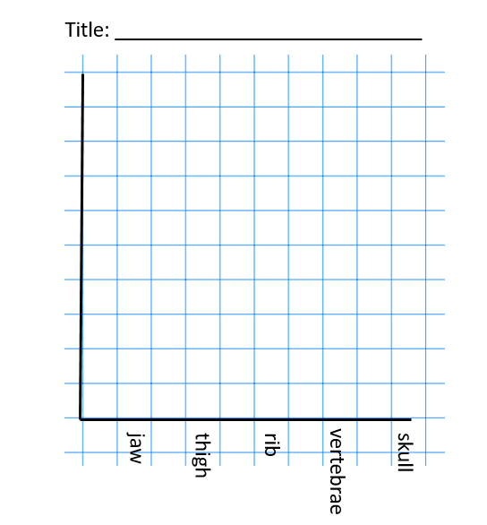

**Challenge 3**

**Once you have completed challenge 2, use your bar chart to answer the following questions:**

1) Which was the most common type of bone? **________________**

2) How many more ribs than vertebrae were there? ________________

**“At least 40 bones were discovered in the pellets altogether.”**

3) Is this statement true or false? ________________

4) Explain how you know.

____________________________________________________________________________________________________________________________________________