**Learning Objective**

* We are learning how to present and interpret data in a bar chart.
* We are learning how to solve 1 step and 2 step questions using information presented in a bar chart.

**Challenge 1**

**This bar chart shows the number of sea creatures found in and around 20 Cornish rock pools. Look carefully at the information and answer the questions below.**

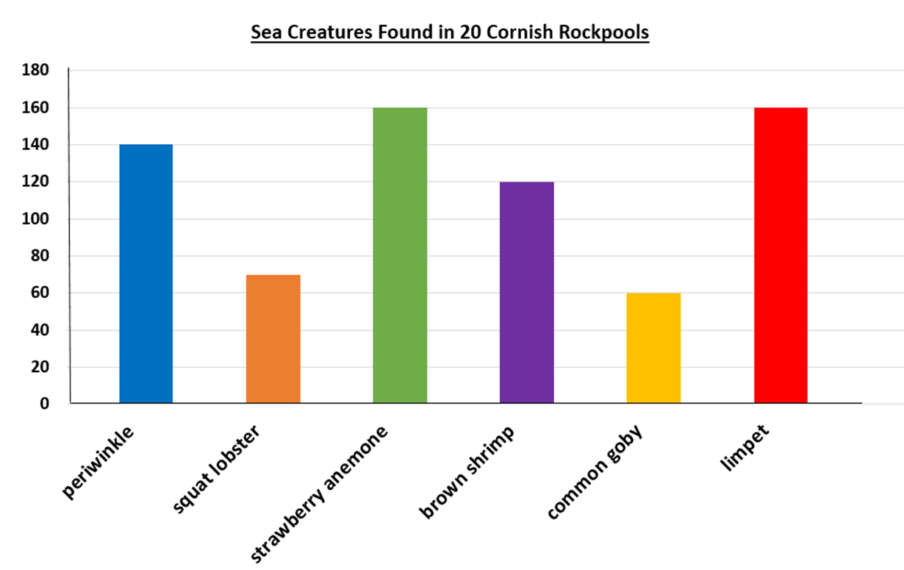

1) How many squat lobsters were found? _________

2) How many different types of sea creature had a quantity greater than 150? __________

3) How many less common squat lobsters than limpets were found? _________

4) How many more strawberry anemones than periwinkles were found? __________

**Martha said, “There is double the amount of squat lobsters than periwinkles.”**

5) Explain the mistake that Martha made.

____________________________________________________________________________________________________________________________________________

______________________________________________________________________

**Challenge 2**

|  |  |  |
| --- | --- | --- |
| **Sea creature** | **Tally** | **Total** |
| **long-spined sea scorpion** | **~~||||~~ ~~||||~~ ~~||||~~ ~~||||~~ |** |  |
| **shanny** | **~~||||~~ ~~||||~~ ~~||||~~ ||** |  |
| **common hermit crab** | **~~||||~~ |||** |  |
| **common starfish** | **~~||||~~ ~~||||~~ ~~||||~~ ||** |  |
| **beadlet anemone** | **~~||||~~** |  |

**This tally chart below shows the different types of sea creature found in 3 rock pools in the UK.**

a) Complete the tally chart.

b) Complete the bar chart to represent the data in the tally chart.

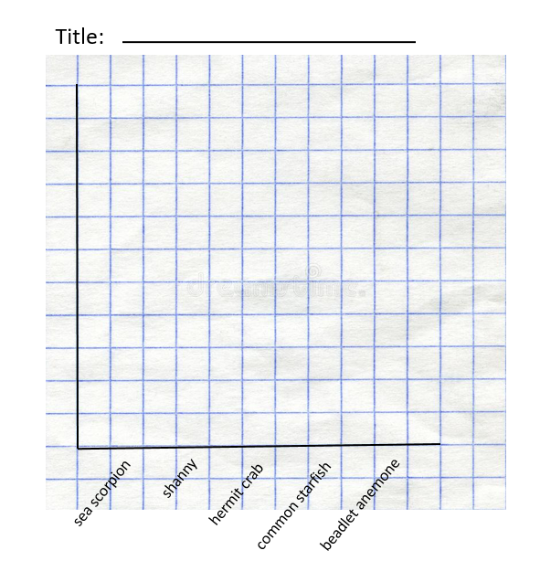

**Challenge 3**

**Use your bar chart to answer the following questions:**

1) Which is the most common type of sea creature? **___________**

2) What is the difference between the number of common starfish found and the number of long-spined sea scorpions found?

**Altogether, there is an odd amount of sea creatures in the 3 UK rock pools.**

3) Is this statement true or false? ___________

4) Explain how you know.

____________________________________________________________________________________________________________________________________________

______________________________________________________________________