**Learning Objective**

We are learning how to solve a natural world problem by using and applying our skills and knowledge of number and measurement **(including addition, multiplication and working with units of length)**.

**The Problem:**

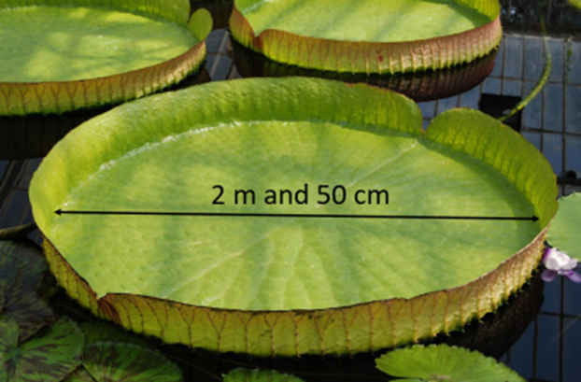

In a remote corner of the Pantanal (the world’s largest wetland habitat), a giant water lily has one particularly large leaf that measures **2 m and 50 cm** across.

**Using the useful fact below, can you work out how many days it took for the leaf to reach this monster size?**

Useful fact

* Giant water lily leaves grow at a rate of around 20 cm every 24 hours.

**Recording:**

*Use this space to show your working out.*

Answer: ________ days