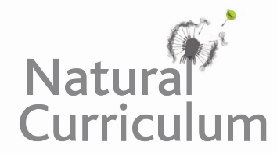**Learning Objective**

We are learning how to solve a natural world problem by using and applying our skills and knowledge of geometry **(including symmetry and visualising).**

**The Problem:**

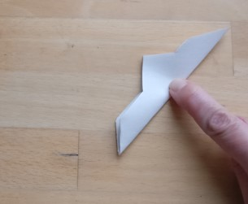Megan decided to make a snowflake from paper. The first snowflake that she made had **four lines of symmetry**.

Having folded a piece of A4 paper several times, she made a number of cuts into it and ended up with the shape opposite.

**Can you visualise in your head what you think Megan’s snowflake looked like when it was opened out?**

**Recording:**

Use this space to draw what you think Megan’s snowflake looked like.

How could you prove that the snowflake you have drawn has four lines of symmetry?

