**Learning Objective**:

We are learning how to solve a natural world problem by using and applying our skills and knowledge of number and measurement **(including time and estimating, and measuring length in cm and m)**.

**The Problem:**

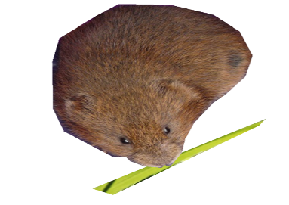

Vincent, the water vole, was enjoying eating the new, high quality grass that had been planted in the Glasgow park that he now called home. It took Vincent **30 seconds** to eat a single blade of grass.

**Q1) How many blades of grass do you think Vincent (and water voles like him) can eat in an hour?**

*Use this space to show your working out.*

Answer: ____________

**Q2) If you laid out all the blades of grass that Vincent ate in a long line, how long would this line be?**

*Use this space to show your working out.*

Answer: _____________

Answer: __________