**Learning Objective**

We are learning how to solve a natural world problem by using and applying our skills and knowledge of number **(including estimation and working with large numbers)**.

**The Problem:**

In the main film clip, we were treated to a starling murmuration, high above the Royal Pier in Aberystwyth. In the clip, the presenter said that there were

**fifty thousand** starlings in the murmuration.

**Do you agree with the presenter? Has he made a reasonable estimate?**

*The following photograph shows a flock of starlings feeding on the ground before they travelled to the coast to join the murmuration. Think carefully about how the photograph could help you answer the above questions.*

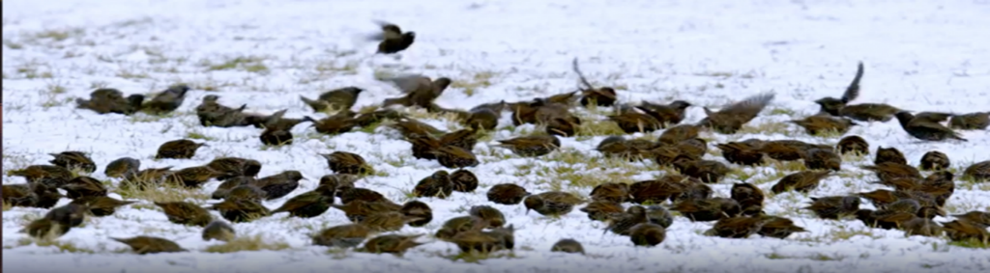

**Recording:**

*Use this space to show your working out.*

**Answer:** I think that the presenter’s estimate is _______________________