**Learning Objective**

We are learning how to solve a natural world problem by using and applying our skills and knowledge of number **(including estimation and finding more than one solution to a problem)**.

**The Problem:**

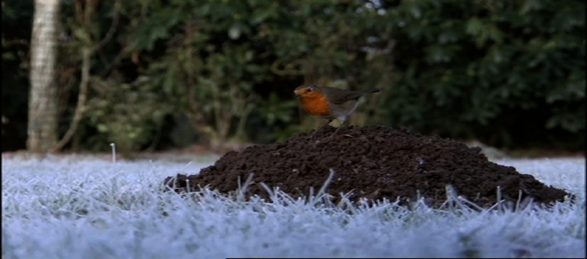It was a cold winter’s day and Robbie the robin was searching for food. Although the ground was frozen solid, a family of moles had created a number of molehills (soft piles of soil), which Robbie knew might contain fat, juicy worms.

Useful facts:

* Adult robins must eat at least ten earthworms a day in the winter.
* You would expect to find 1 or 2 earthworms in a child-sized bucketful of soil.

**How will you use these useful facts to answer the following questions?**

Q1) What is the **smallest** number of molehills that Robbie would need to visit on a single winter's day?

*Use this space to show your working out.*

Answer: ____________________

Q2) What is the **largest** number of molehills that Robbie would need to visit on a single winter's day?

*Use this space to show your working out.*

Answer: __________________