**Learning Objective**

We are learning how to solve a natural world problem by using and applying our skills and knowledge of number **(including doubling and addition)**.

**The Problem:**

Beaky made three mud nets by beating his tail against the sea bed. In the second mud net, there was double the amount of fish than in the first mud net. In the third mud net, there was double the amount of fish than in the second mud net.

**If Beaky caught 112 fish in total, how many fish were caught in each of the three mud nets?**

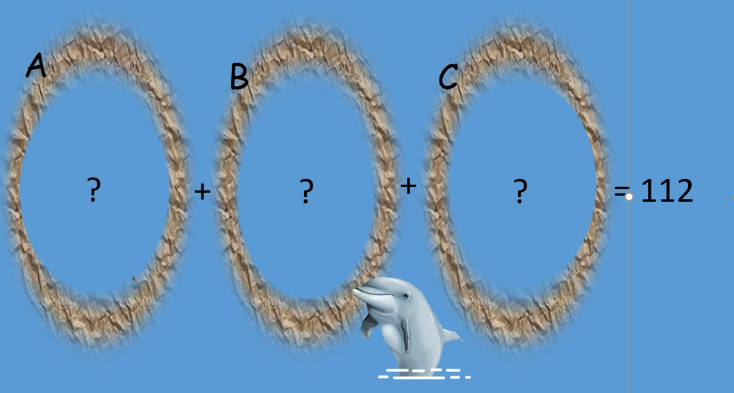

**Recording:**

Use this space to show your working out.

**Answer: Mud net A = ____________ fish**

**Mud net B = ____________ fish**

**Mud net C = ____________ fish**