**Learning Objective**

We are learning how to solve a natural world problem by using and applying our skills and knowledge of number **(including addition, subtraction and multiplication)**.

**The Problem:**

The animals that visited Hotel Armadillo are featured on the list below. The number inside the brackets shows the number of letters in each animal name.

fox (3) ocelot (6) tortoise (8) anteater (8) armadillo (9)

**Can you work out which animals could have visited Hotel Armadillo?**

(Note: They don’t all have to visit the burrow and you can have more than one type of animal visiting. There is more than one answer to this problem!)

**Recording:**

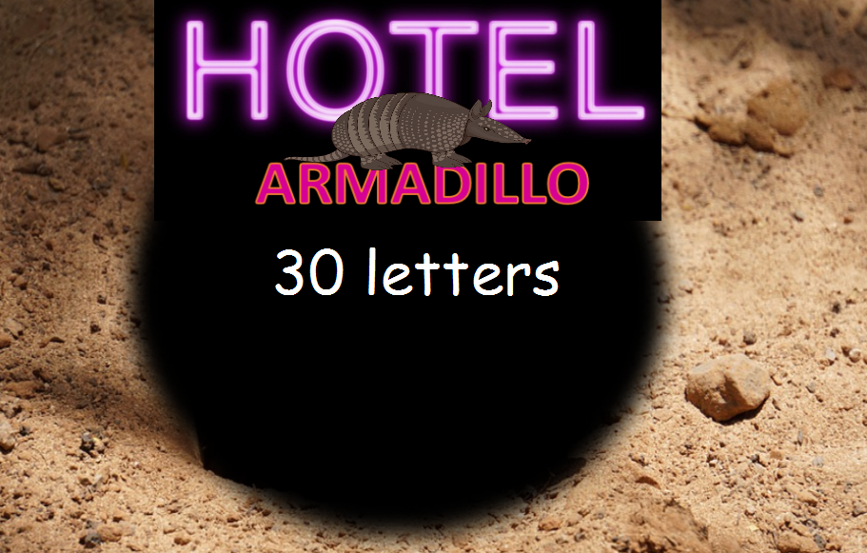Use the table below to record the different combinations of animals that could have visited Hotel Armadillo.

|  |  |  |
| --- | --- | --- |
| **Animals** | **Number sentence** | **Total number of letters** |
| **10 foxes** | **3 x 10 = 30** | **30** |
|  |  |  |
|  |  |  |
|  |  |  |
|  |  |  |