**Learning Objective**

We are learning how to multiply by 8.

**Challenge 1**

1) How many tarantula legs can you see altogether?

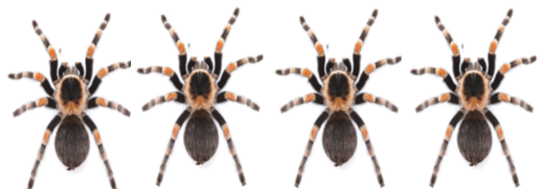

Answer: + + + = Answer: x =

2) How many scorpion legs can you see altogether?

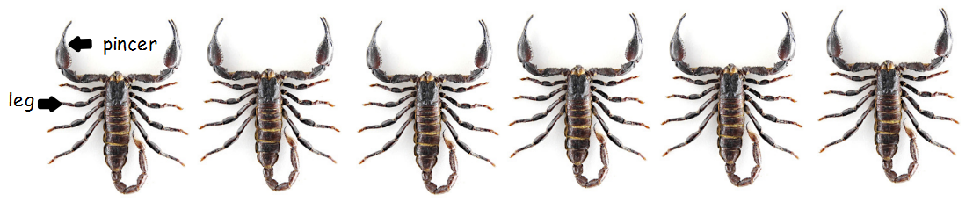

Answer: + + + + + =

3) The arachnids below are ticks. They are parasites that feed on the blood of other animals. How many tick legs can you see altogether?

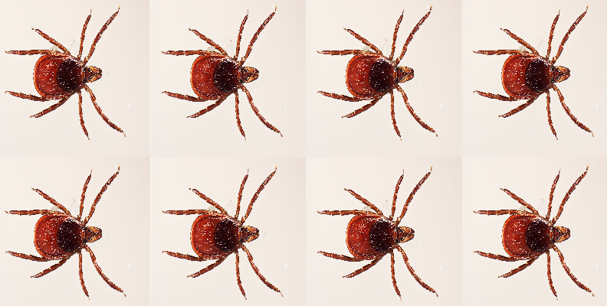

+

+

+

+

+

+

+

Answer: + + + + + + + =



+

Answer: x =

**Challenge 2**

**Read each word problem carefully and highlight the important information.**

Rupert found seven spider webs in his shed. Each web had a common house spider at the centre of it. None of these spiders had legs missing.

**How many spider legs were there altogether in Rupert’s shed?**



Answer:

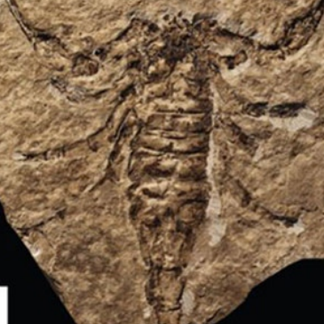

5) A fossil hunter discovered three fossilised scorpions in a quarry before he ate his lunch. After lunch, he discovered six more fossilised scorpions. Each fossil was approximately 350 million years old. None of the scorpions had legs missing.

**How many scorpion legs did the fossil hunter discover altogether?**

Answer:

**Did you know?**

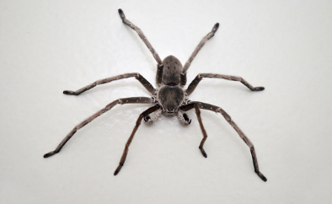The giant huntsman spider has a leg span of up to 30 cm, making it the largest spider by diameter. It is often described as being "the size of a dinner plate." The largest spider by weight is the Goliath bird-eater tarantula. It can weigh up to 170 grams. Despite, its name, this spider rarely eats birds.

giant huntsman

6) Deep in a cave, an explorer shone his torch on some giant huntsman spiders. In total, he counted 94 legs. They all had a full set of legs apart from one spider.

**How many legs did the spider without a full set have?**



Answer:

**Challenge 3  
Using your knowledge of the natural world and animals, write your own word problem based on the multiples-of-8 bar below.**

|  |  |  |  |  |  |  |
| --- | --- | --- | --- | --- | --- | --- |
| **8** | **8** | **8** | **8** | **8** | **8** | **8** |

**______________________________________________________________________________________________________________________________________________________________________________________________________________________________**