**Learning Objective**

We are learning how to multiply by 4.

**Challenge 1**

1) How many lion cub legs can you see altogether?

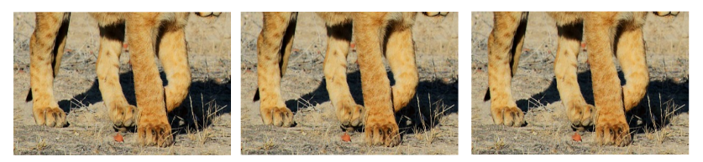

Answer: + + = Answer: x =

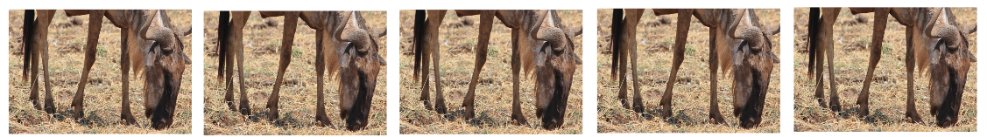2) How wildebeest legs can you see altogether?



Answer: + = Answer: x =

3) How many zebra legs can you see altogether?

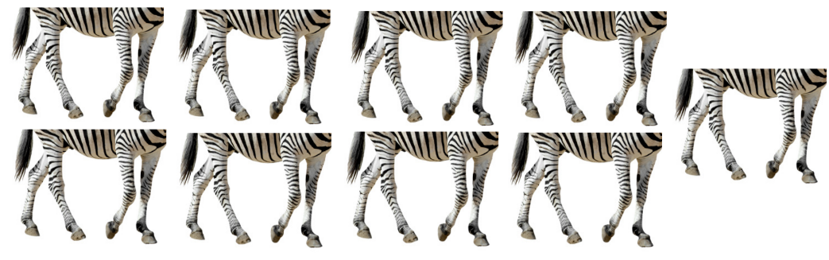

Answer:

+ + =

Answer: x =

**Challenge 2**

**Read each word problem carefully and highlight the important information.**

4) Four wildebeest, three zebras and three elephants were cooling down at an African waterhole.

**How many animal legs would you be able to count at this waterhole?**



Answer:

5) In the morning, four elephants were walking along a dusty road. By the afternoon this number had doubled.

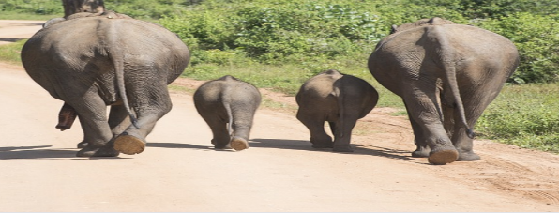**How many elephant legs would you be able to count in the afternoon?**



Answer:

**Did you know?**

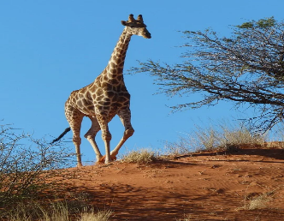Of all the different quadrupeds on the planet, giraffes have the longest legs. These towering animals can reach heights of six metres overall and can have legs that are more than two metres high. A group of giraffes is called a tower!

6) From the back of his safari jeep, Joey saw a tower of giraffes feeding from the high branches of some trees. He counted a total of 48 giraffe legs.

**How many giraffes did Joey see from the back of his safari jeep?**



Answer:

**Challenge 3  
Using your knowledge of the natural world and animals, write your own word problem based on the multiples-of-4 bar below.**

|  |  |  |  |  |  |  |
| --- | --- | --- | --- | --- | --- | --- |
| **4** | **4** | **4** | **4** | **4** | **4** | **4** |

**______________________________________________________________________________________________________________________________________________________________________________________________________________________________**