**Learning Objective**

We are learning how to solve a natural world problem by using and applying our skills and knowledge of number **(including estimation, addition and counting)**.

**The Problem:**

At the end of his fascinating talk on cheetahs, Andy was asked the following question:

“How many spots does an adult cheetah have?”

**Use the photograph below and your number skills to help Andy find an answer to this fabulous question.**

**Recording:**

You may want to write over the photograph and/or use the space below to carry out any calculations that will help you arrive at the estimated number of spots.

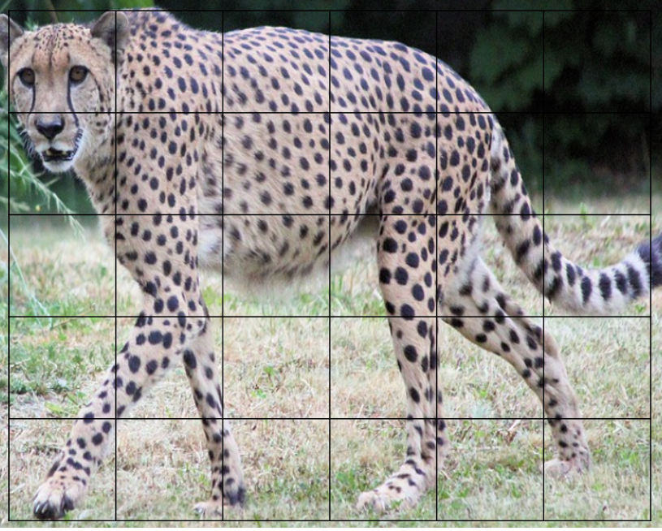



Answer: I estimate that a cheetah has ______________ spots