**Learning Objective**

We are learning how to solve a natural world problem by using and applying our skills and knowledge of number **(including addition, odd and even numbers, multiples of 10)**.

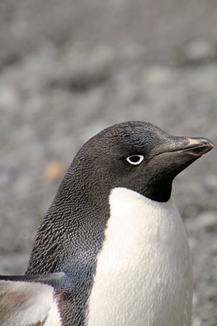**The Problem:**

Oh dear! While fishing out at sea, some of Arwel’s nest stones were stolen by a neighbour.

**Use the clues below to find out exactly how many stones were stolen from Arwel’s nest.**

**Clues**

**1) The number is below 50.**

**2) The number is an odd number.**

**3) The sum of the number’s digits is seven.**

**4) The number is 3 away from a multiple of 10.**

**Recording:**

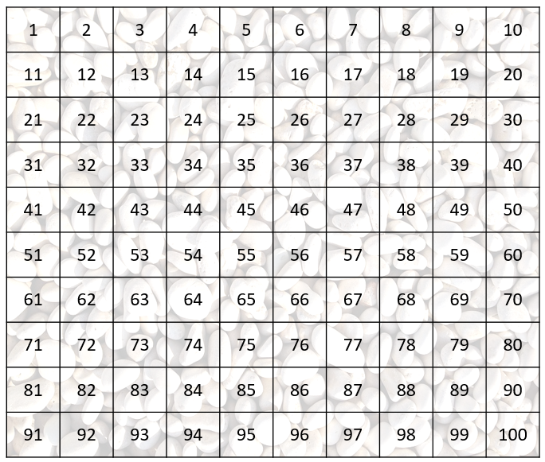You can use the 100 square below to work methodically and cross off any numbers that cannot be the answer.

Answer: ______________ stones were stolen.