**Learning Objective**

We are learning how to solve a natural world problem by using and applying our skills and knowledge of number **(including addition of single digit numbers).**

**The Problem:**

Duke is very hungry and would love to eat the acorn at the end of the man-made maze. However, the acorn is behind a gate and it will only open if he runs a route through the maze that adds up to **40**. Can you help Duke claim his prize?

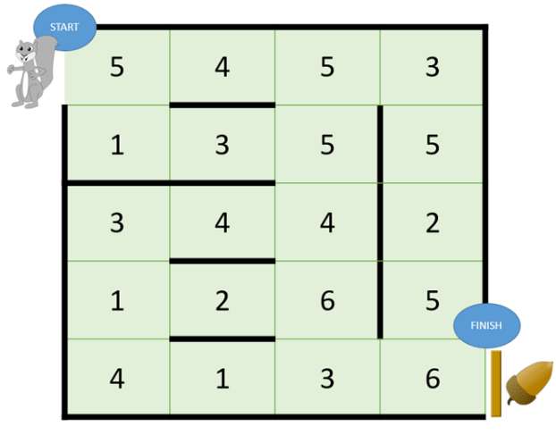**There are lots of copies of the maze below for you to test different routes.**

Total: __________________

Total: __________________



Total: __________________

Total: __________________



Total: __________________

Total: __________________