**Learning Objective**

We are learning how to subtract a 3-digit or 4-digit number from a 4-digit number using column subtraction **(with more than one exchange, including exchanges across more than one place value).**

**Challenge 1**

**Read each word problem carefully and highlight the important information. Solve each word problem by drawing 100s, 10, and 1s counters and column subtraction.**

1) A herd of 1,245 walruses were fast asleep on an ice sheet when a polar bear launched an attack. 436 walruses dived into the sea and headed north. The remaining walruses dived into the sea and headed south. **How many walruses headed south?**

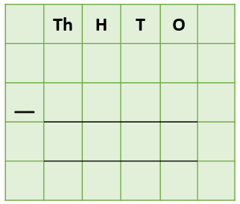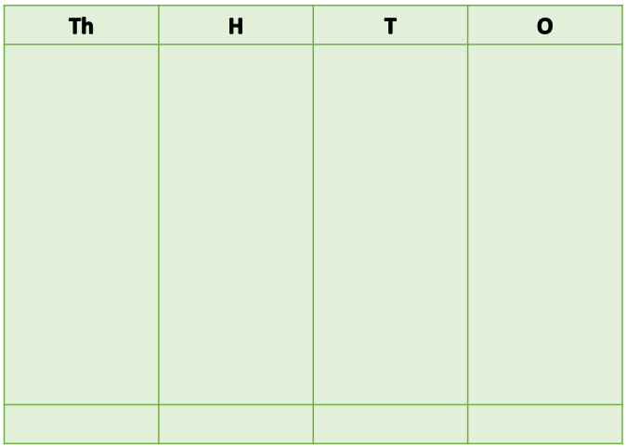

Answer:

2) Wally the walrus drifted on an iceberg for a total of 4,563 metres. Wally was asleep on the iceberg while it drifted 2,644 metres. **Wally was awake for the remainder of the journey. How far did Wally drift on the iceberg while he was awake?**



Answer:

3) On a single day, a large, hungry walrus (that weighed 1,015 kilograms) ate 3,045 shellfish. Of these shellfish, 853 were mussels. The remaining shellfish were clams. **How many clams did the hungry walrus eat on this day?**



Answer:

4) 2,917 miles north of Bristol, a female walrus made a dive underwater that lasted for 487 seconds. At the same time, a killer whale, who was chasing the walrus, made a dive underwater that lasted for 1,002 seconds. **How much longer was the killer whale underwater than the walrus?**



Answer:

5) The greatest threat to walruses comes from global warming and the melting of sea ice. Scientists have been using satellite photographs to study sea ice in the Arctic since 1979.

**How many years have scientists being using satellite photographs to show the effects of global warming on Arctic sea ice?**





Answer:

**Challenge 2  
Using your knowledge of walruses and some of the words from the Word Wall, write your own word problem that has more than one exchange or an exchange across more than one place value. Use column subtraction to write your answer to the problem.**

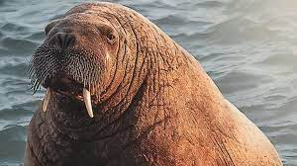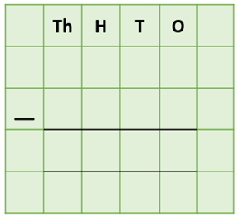**______________________________________________________________________________________________________________________________________________________________________________________________________________________________**

eaten

**Word Wall**

tusks

sleeping

polar bear

clams

walrus

iceberg

weighed

attacked