**Learning Objective**

We are learning how to subtract a 3-digit or 4-digit number from a 4-digit number using column subtraction **(with more than one exchange, including exchanges across more than one place value).**

**Challenge 1**

**Read each word problem carefully and highlight the important information. Solve each word problem by drawing 100s, 10, and 1s counters and column subtraction.**

1) In the Atlantic Ocean, 2,345 brittle stars were being hunted by their larger cousins – starfish. Of these brittle stars, 1,426 had buried themselves in the sand and the rest were hiding amongst sea anemones. **How many brittle stars were hiding amongst the sea anemones?**

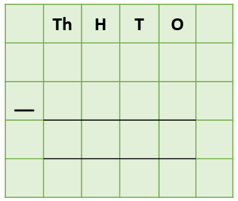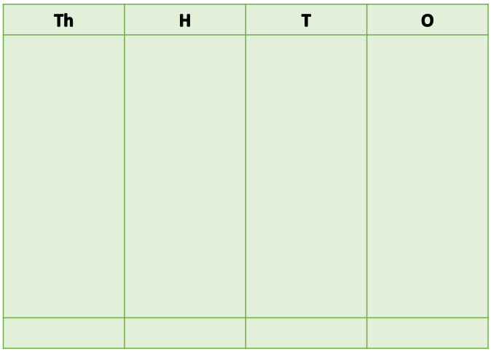

Answer:

2) A large cluster of 4,367 brittle stars were feeding on the ocean floor. Of these brittle stars, 2,529 had one or more arms missing. The remaining brittle stars were complete (with no arms missing). **How many brittle stars had no arms missing?**



Answer:

3) 2,300 metres below the surface of the ocean, a female brittle star released 4,247 eggs into the water. Of these eggs, 1,454 developed into young brittle stars. **The remaining eggs did not develop. How many eggs did not develop into brittle stars?**



Answer:

4) Two large basket stars were feeding next to each other on the floor of the Red Sea. **Together, they weighed 4,050 grams. If one of the basket stars weighed 274 grams, what did the other basket star weigh?**



Answer:

5) An experienced diver had made 7,867 dives in all of the world’s oceans. During this period, he spotted 364 different types of brittle star. **If there are 1,800 known types of brittle star in the world, how many different types had the diver not yet seen?**





Answer:

**Challenge 2  
Using your knowledge of brittle stars or starfish and some of the words from the Word Wall, write your own word problem that has more than one exchange or an exchange across more than one place value. Use column subtraction to write your answer to the problem.**

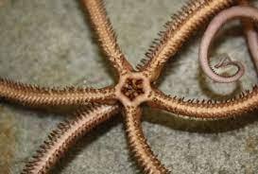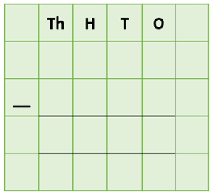**______________________________________________________________________________________________________________________________________________________________________________________________________________________________**

eaten

lost

brittle star

caught

arms

feeding

diver

plankton

seabed

**Word Wall**