**Learning Objective**

We are learning how to add numbers with up to 4 digits using column addition **(with one exchange).**

**Challenge 1**

**Read each word problem carefully and highlight the important information. Solve each word problem by drawing 1000s, 100s, 10s and 1s counters and column addition**

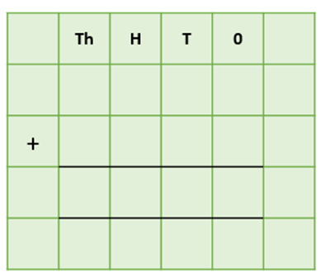1) Between 9 pm and 10 pm, a pipistrelle bat ate 1,245 mosquitoes. Between 10 pm and 11 pm, the same bat ate a further 346 mosquitoes. **How many mosquitoes did this bat eat between 9 pm and 11pm?**



Answer:

2) In 2019, a farmer put 1,345 kilograms of bat droppings (guano) on his field to help his crops grow. The following year, he put 1,247 kilograms of bat droppings on his field. **What was the total weight of bat droppings used by the farmer in 2019 and 2020?**



Answer:

3) Near a cave’s entrance, 2,336 vampire bats were hibernating for the winter. (Hibernation is a period of extended sleep when food is in short supply.) At the back of this cave, a further 2,182 vampire bats were hibernating. **How many bats were hibernating in the cave altogether?**





Answer:

4) In March, a flying fox (fruit bat) made a journey of 1,823 kilometres to find the ripest fruit to eat. In April, it made a journey of 1,436 kilometres to find fruit, and in May it made a journey of 1,356 kilometres. **What was the total distance covered by the flying fox in March and May?**



Answer:

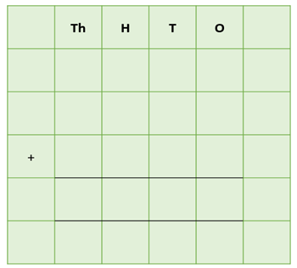5) In a large area of forest that measured 1,356 square kilometres, twelve bat boxes were attached to the trunks of trees. In five of these bat boxes, a total of 1,453 pipistrelle bats were roosting. In another five boxes, a total of 2,735 pipistrelles were roosting. In the final two boxes, 811 pipistrelles were roosting. **How many pipistrelle bats were roosting in this forest?**

Answer:

**Challenge 2  
Using your knowledge of bats and some of the words from the Word Wall, write your own word problem that requires more than one exchange. Using column addition, write the solution to your word problem on the grid below.**

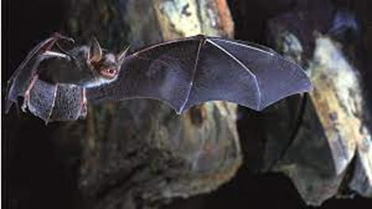______________________________________________________________________________________________________________________________________________________________________________________________________________________________



grooming

hanging

cave

pipistrelle

flying

feeding

roosting

insects

colony

**Word Wall**

long-legged

scrambled

poisonous

brightly coloured

leapt

amphibian

fingernail-sized

dwarf frog

undergrowth

rainforest