**Learning Objective**

We are learning how to add numbers with up to 3 digits using column addition **(with one or more exchanges).**

**Challenge 1**

**Read each word problem carefully and highlight the important information. Solve each word problem by drawing 100s, 10, and 1s counters and using column addition.**

1) Sadly, an egg collector had 678 eggs in his collection. Of these eggs, 124 were eagle eggs and 136 were owl eggs. **How many eagle and owl eggs did he have altogether?**

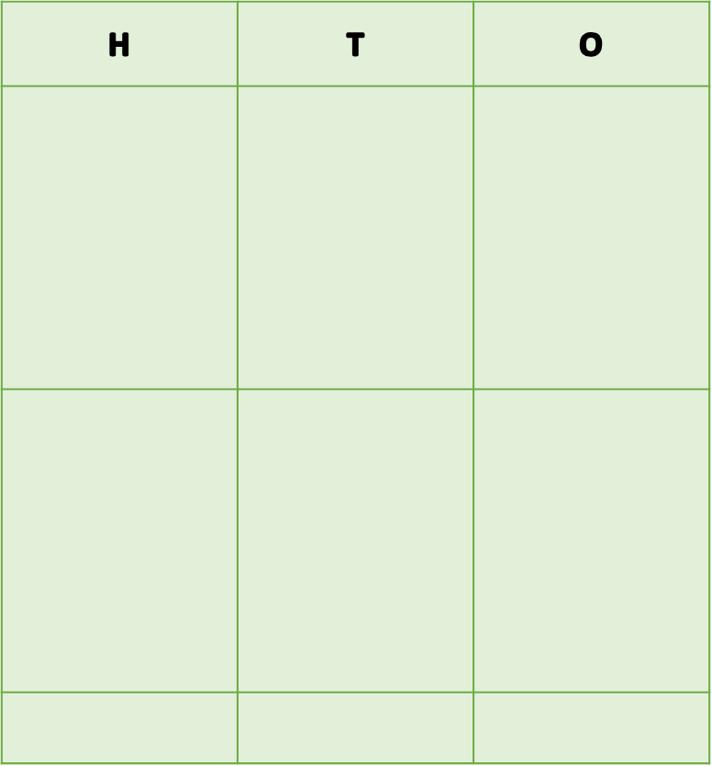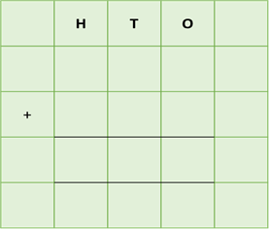

Answer:

2) Over the course of ten years, a keen birdwatcher spotted over 1,378 birds of prey. She spotted 125 golden eagles in Europe and a further 128 golden eagles in northern Africa and North America. **How many golden eagles did the birdwatcher spot altogether?**





Answer:

3) There were 354 golden eagles in Finland and 447 golden eagles in France. 267 of these birds had tags around their legs so that scientists could keep a check on their numbers in the wild. **How many eagles were there altogether in these two countries?**





Answer:

4) A rabbit ran 345 metres towards its burrow before freezing after spotting a golden eagle soaring high above. Its burrow was now only 156 metres away. **If it made it safely to its burrow, how far had it run in total?**



Answer:

5) A bald eagle built an enormous nest (eyrie) from sticks. In 2019 it weighed 345 kilograms. The following year, 273 kilograms of sticks were added to the nest, making it even heavier.

By the end of 2021 a further 82 kilograms of sticks had been added to it.

**How heavy was the bald eagle’s nest by the end of 2021?**

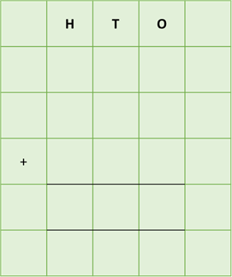

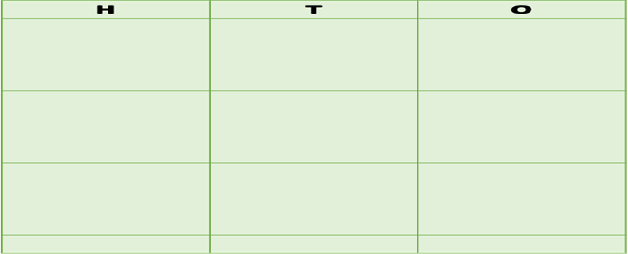

Answer:

**Challenge 2  
Using your knowledge of eagles and some of the words from the Word Wall, write your own word problem that requires more than one exchange. Using column addition, write the solution to your word problem on the grid below.**

long-legged

scrambled

poisonous

brightly coloured

**______________________________________________________________________________________________________________________________________________________________________________________________________________________________**

altogether

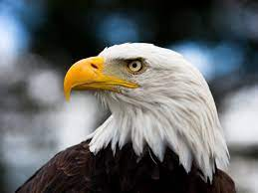

prey

sticks

distance

salmon

nest/eyrie

golden eagle

mountains

soaring

**Word Wall**