**Learning Objective**

We are learning how to add numbers with up to 4 digits, using column addition **(with one or more exchanges).**

**Challenge 1**

**Read each word problem carefully and highlight the important information. Solve each word problem by drawing 1000s, 100s, 10s and 1s counters and column addition.**

1) 225 kilometres out at sea, a hungry emperor penguin was hunting for fish. She dived down 436 metres and spotted prey another 128 metres beneath her. She got her catch and set the record for the deepest recorded dive by a penguin. **How far down did the emperor penguin dive in total?**

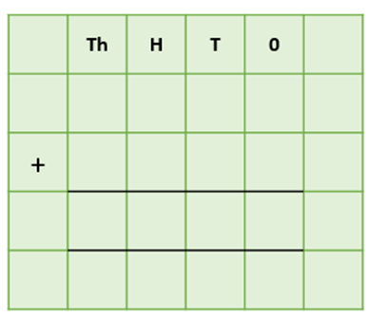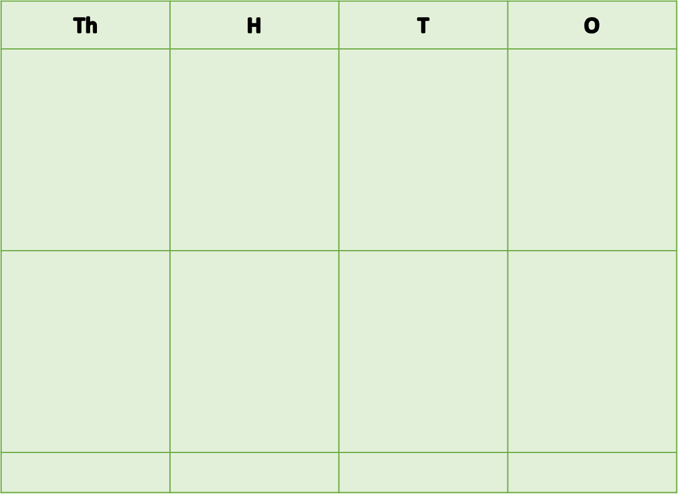

Answer:

2a) A group of scientists, who were studying chinstrap penguins, travelled 1,828 kilometres from Antarctica’s Halley Research Station to the South Orkney Islands. They then travelled 1,802 kilometres to Bouvet Island. **How far did they travel in total?**



Answer:

2b) For their second trip, the group of scientists travelled 2,547 kilometres from Bouvet Island to the South Sandwich Islands. They returned to Halley Research Station, which was a journey of 2,492 kilometres. **How far did they travel in total on their second trip?**





Answer:

4). In the winter months, **male** emperor penguins huddle together in huge numbers for warmth. In one particular huddle, there were 2,267 emperors. They were later joined by a further 1,683 emperors**.** 3,815 eggs belonging to this huddle hatched successfully. **How many emperor penguins were there altogether in the huddle?**



Answer:

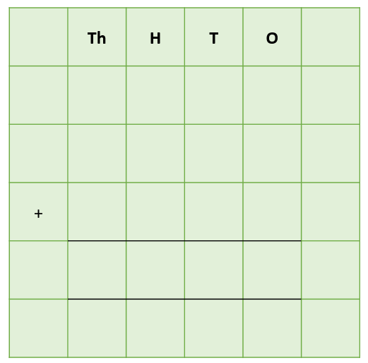3) Over a period of three weeks, a chinstrap penguin parent brought back a huge amount of krill to its two hungry chicks. In the first week, it brought back 628 grams of krill. This was followed by 1,492 grams of krill in the second week and 2,325 grams of krill in the third week. **What was the total weight of the krill that was brought back to the chicks in this 3-week period?**

Answer:

**Challenge 2  
Using your knowledge of penguins and some of the words from the Word Wall, write your own word problem that requires more than one exchange. Using column addition, write the solution to your word problem on the grid below.**

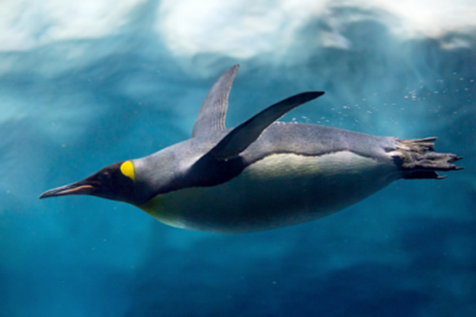______________________________________________________________________________________________________________________________________________________________________________________________________________________________

**Word Wall**

crèche

fishing

diving

huddling

ice sheet

emperor

chicks

colony

chinstrap

long-legged

scrambled

poisonous

brightly coloured

leapt

amphibian

fingernail-sized

dwarf frog

undergrowth

rainforest