**Learning Objective**

We are learning how to add numbers with more than 4 digits, using the formal written method of column addition **(more than one exchange).**

**Challenge 1**

**Read each word problem carefully and highlight the important information. Solve each word problem using column addition.**

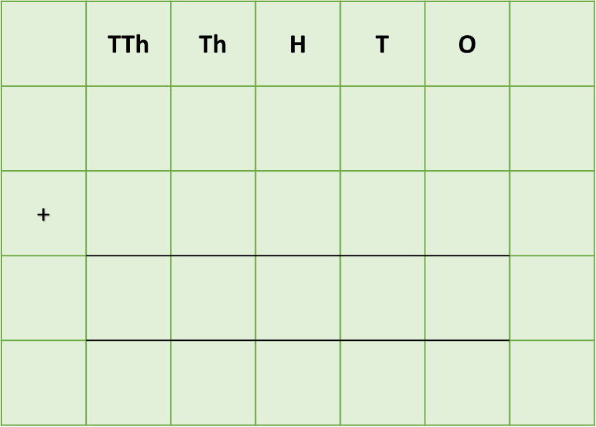

1) In a pine forest, a wood ant colony ate 21,854 insects in the first year, 17,226 insects in the second year and 19,325 ants in the third year.

**What was the total number of insects eaten by the wood ants in the first and third year?**

Answer:

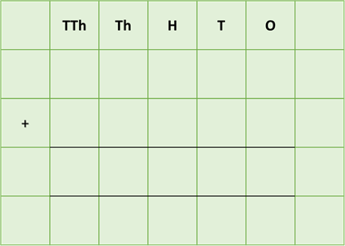2) A dome-shaped wood ant nest was over 215 centimetres high. Its roof was made from 18,652 pine needles, 3,260 twigs and 11,906 blades of grass.

**What was the total number of pine needles and twigs in the roof of the wood ant nest?**

Answer:

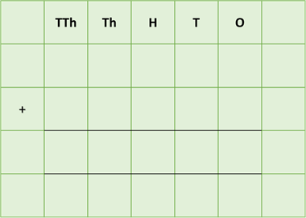 3) Two rafts (made from the bodies of thousands of living fire ants) were floating side-by-side down a river. One raft contained 14,374 ants, while the other contained 16,255 ants. Just before the rafts reached the safety of the riverbank, a shoal of fish gobbled up 11,675 fire ants from the rafts.

**How many ants were there altogether in the two ant rafts before they encountered the shoal of fish?**

Answer:



4) 15,654 leaf cutter ants were responsible for cutting leaves with their mandibles and bringing the leaf tips into their nest. In January, they brought 11,674 leaf tips into their nest. The following month, a further 10,831 leaf tips were brought into their nest.

**How many leaf tips were brought into their nest during this two month period?**



Answer:

Answer:

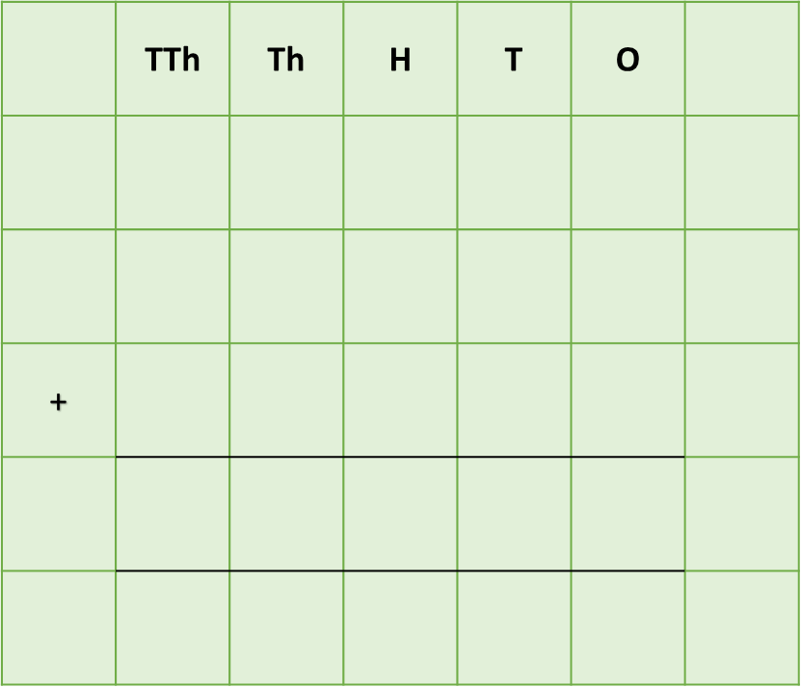5) A swarm of male ants, all of whom had grown a pair of wings and were looking to mate with a queen, left their colony. 29,965 of these winged ants flew off in a northerly direction, while 11,124 headed in a southerly direction. A further 3,456 ants flew off in an easterly direction. Of the remaining ants in the colony, 17,123 were eaten by predators.

**How many male ants flew away from the colony?**

Answer:

**Challenge 2  
Using your knowledge of ants and some of the words from the Word Wall, write your own word problem that requires two (or more) exchanges. Show the solution to your word problem using column addition.**

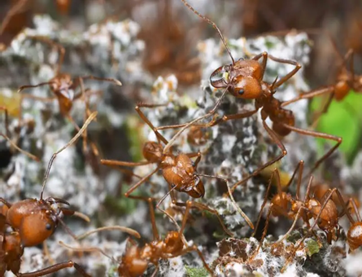



**Word Wall**

colony

nest

ants

returned

attacked

queen

soldier

worker