**Learning Objective**

We are learning how to add numbers with more than 4 digits, using the formal written method of column addition **(with more than one exchange).**

**Challenge 1**

**Read each word problem carefully and highlight the important information. Solve each word problem using column addition.**

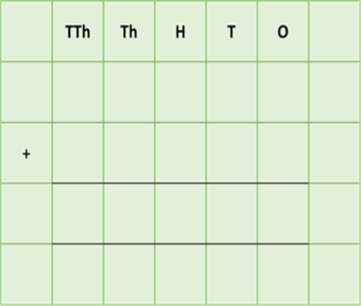

1) In a woodland, 20,308 earthworms dragged 16,305 brown leaves and 2,809 green leaves into their burrows.

**How many leaves were dragged altogether into the earthworms’ burrows?**

Answer:

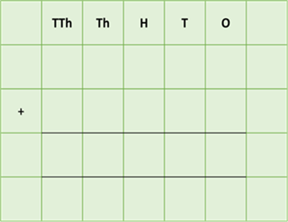2) On a long beach, 4,050 sandworms had created a huge number of casts. (A cast is a string of sand or soil that has passed through an earthworm’s gut.) There were 15,675 short casts and 12,245 long casts.

**How many sandworm casts were there altogether on the beach?**

Answer:

****3) Earthworms come in a variety of colours. They can be grey, pink, green, brown or even blue! In an area of woodland, there were 14,654 pink earthworms, 8,901 green earthworms and 6,637 blue earthworms.

**What was the total number of pink earthworms and blue earthworms in this area of woodland?**

Answer:

****4) A family of badgers ate thousands of earthworms over the course of a year. The mother (the sow) ate 26,509 earthworms, her cubs ate 6,099 earthworms and the father (the boar) ate 33,945 earthworms.

**How many earthworms did the father and cubs eat over the course of the year?**

Answer:

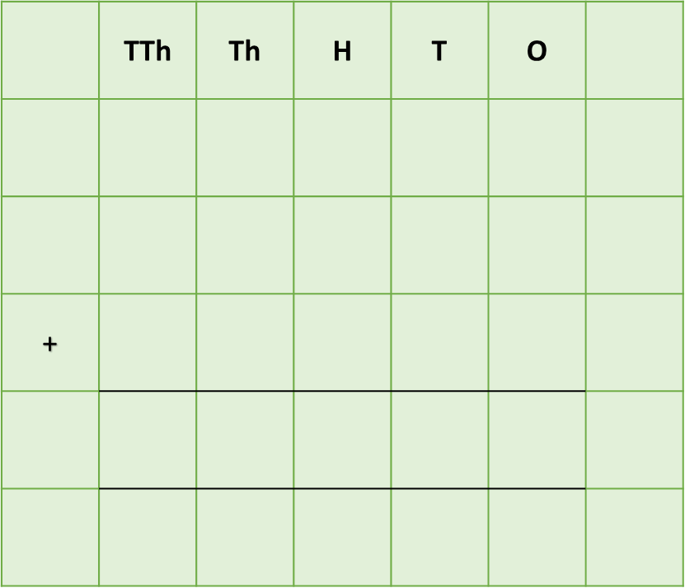5) In a woodland, 14,673 earthworms were at the surface in the leaf litter. Meanwhile, 35,778 earthworms were burrowing their way through the topsoil and 34,229 earthworms were burrowing their way through the subsoil.

**What was the combined number of earthworms in the leaf litter, the topsoil and the subsoil?**

Answer:

**Challenge 2  
Using your knowledge of worms and some of the words from the Word Wall, write your own word problem that requires two (or more) exchanges. Using column addition, write the solution to your word problem on the grid below.**

______________________________________________________________________________________________________________________________________________________________________________________________________________________________

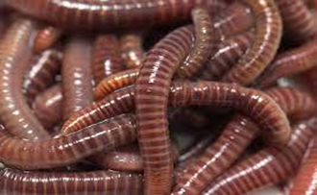

casts

badger

surface

burrow

soil

worms

**Word Wall**



compost bin

micro organism