**Learning Objective**

We are learning how to add numbers with more than 4 digits using the formal written method of column addition **(more than one exchange).**

**Challenge 1**

**Read each word problem carefully and highlight the important information. Solve each word problem using column addition.**

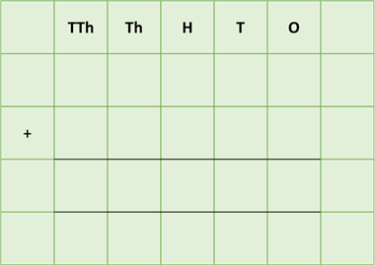1) Two beaches, which were 12,567 kilometres apart, were littered with thousands of tiny plastic, The pellets posed a grave threat to several turtle species. On one of the beaches, there were 24,675 pellets. On the other beach, there were 32,728 pellets.

**How many plastic pellets were there altogether on the two beaches?**

Answer:

****2) In one particular arribada, 427,340 olive ridley female turtles came to shore. 24,567 of these turtles laid between 50 and 60 eggs, while 27,328 turtles laid between 60 and 70 eggs.

**How many olive ridley turtles laid between 50 and 70 eggs?**

Answer:

 3) 30,500 green turtle hatchlings found their way into the sea under the light of the moon. Of these hatchlings, 9,659 were sadly caught up in fishing nets and drowned, while a further 13,998 died in an oil spill. The remaining hatchlings made it to adulthood.

**How many turtle hatchlings did not make it to adulthood?**

Answer:

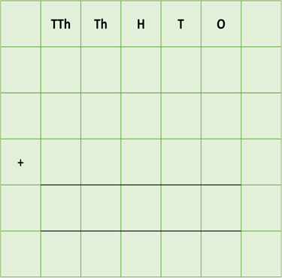4) A sea turtle conservation organisation saved 97,278 turtle eggs from being eaten by humans at 40 key nesting sites around the world. The organisation raised a total of £22,345 from donations in its first year, £19,458 in its second year and £8,878 in its third year.

**How much money did the organisation raise from donations in this three-year period?**

Answer:



5) In its lifetime, a 30-year old leatherback travelled a total distance of 344,456 kilometres. The furthest it swam in

a single year was 11,999 kilometres, followed by 10,779 kilometres and 8,879 kilometres. The shortest distance it swam in a year was 7,678 kilometres.

**What was the combined distance of the loggerhead’s three longest journeys?**

Answer:

**Challenge 2  
Using your knowledge of turtles and some of the words from the Word Wall, write your own word problem that requires at least 3 exchanges. Using column addition, write the solution to your word problem on the grid below.**

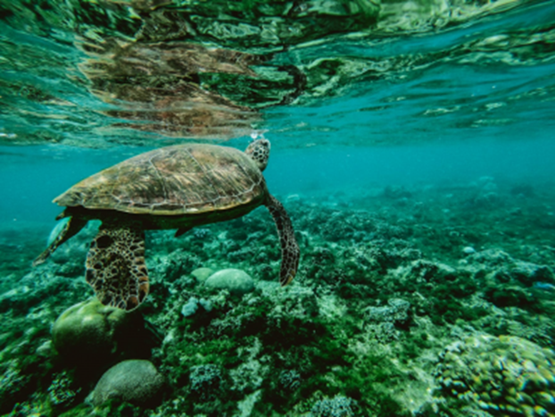

**Word Wall**



hatchling

eggs

arribada

predators

plastic pellets

migrate

olive ridley

nest

foraged