**Learning Objective**

We are learning how to add numbers with more than 4 digits using the formal written method of column addition **(more than one exchange).**

**Challenge 1**

**Read each word problem carefully, and highlight the important information. Solve each word problem using column addition.**

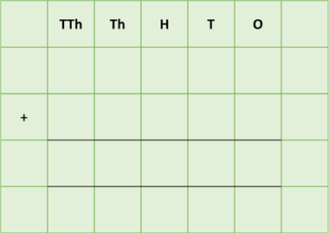1) At precisely 18:45, a flock of 13,656 starlings landed in a reed bed, where they would be roosting (sleeping) for the night. Moments later, another flock of 11,728 starlings landed in the reed bed.

**How many starlings were roosting in this particular reed bed?**

Answer:

****2) A super flock of 54,325 starlings split into three smaller flocks. One flock, which was shaped like a mushroom and contained 18,876 starlings. Another flock was shaped like a dolphin and contained 13,145 starlings. The remaining flock was arrow-shaped.

**How many starlings were there altogether in the dolphin-shaped and mushroom-shaped flocks?**

Answer:

****3) A flock of 46,658 starlings landed on a meadow and ate 13,352 leather jackets (the larvae of crane flies) in the morning, 14,628 leather jackets in the afternoon and 18,678

leather jackets in the early evening.

**How many leather jackets did the flock of starlings eat altogether in the morning and the evening?**

Answer:

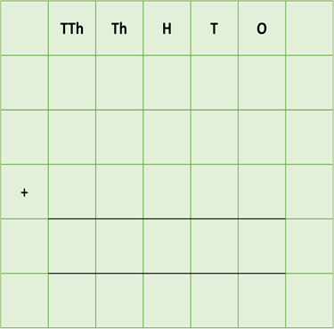4) On Lake Nakuru in Kenya, 76,325 birds had gathered. This included a flock of 34,356 lesser flamingos and a flock of 9,997 greater flamingos, both of whom were feeding on algae. There was also a flock of 11,345 pelicans on the lake.

**How many flamingos and pelicans were feeding in Lake Nakuru altogether**?

Answer:

5) In the Camargue region of southern France, 12,378 greater flamingo eggs hatched after 28 days of incubation, 18,452 eggs hatched after 29 days and 9,999 eggs hatched after 30 days of incubation. Sadly, from these eggs, 8,956 flamingo chicks did not make it to adulthood due to pollution in their wetland habitat.

**What was the combined number of greater flamingo eggs that hatched after incubation periods of 28, 29 and 30 days?**

Answer:

**Challenge 2  
Using your knowledge of starlings or flamingos and some of the words from the Word Wall, write your own word problem that requires at least 3 exchanges. Show the solution to your word problem using column addition.**

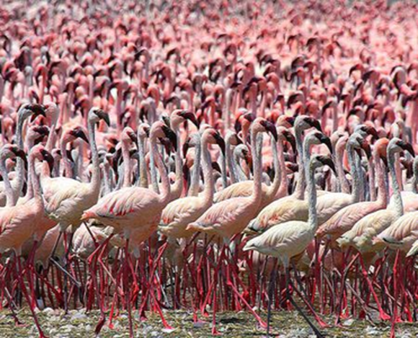__________________________________________________________________________

**Word Wall**



murmuration

roost

starlings

flamingo

predator

flock

feeding

breeding

formation