**Learning Objective**

We are learning to use commas in lists.

**Challenge 1**

**Use your proofreading pen or pencil to add commas to the correct places in the following sentences:**

1. Spectacled bears have shaggy fur long claws strong jaws and white circles around their eyes.
2. Spectacled bears are mainly vegetarian and like to eat fruit berries cacti and honey.
3. Spectacled bears are able to dig holes climb trees and balance on broken branches.
4. Animals that live in the Andes Mountains include alpacas chinchillas yellow-tailed monkeys and South American foxes.

**Challenge 2**

**Take out the unnecessary ‘ands’ from these sentences and rewrite them as a list.**

1) In the Andes mountains, you can see forests and lakes and deserts and even glaciers.

________________________________________________________________________________________________

2) The spectacled bear has wide jaws and sharp claws and long front legs to allow it to hunt and climb.

________________________________________________________________________________________________

3) The spectacled bear eats bromeliad plants and birds eggs and palm nuts and berries.

**______________________________________________________________________**

**Challenge 3**

You have been asked to rewrite the narration for the main clip that featured a spectacled bear eating a bromeliad. Try to use some of the descriptive words from the Word Wall and include two list sentences that are correctly punctuated. You could start with the following sentence:

**Deep in the rainforest, a spectacled bear was climbing a tree.**

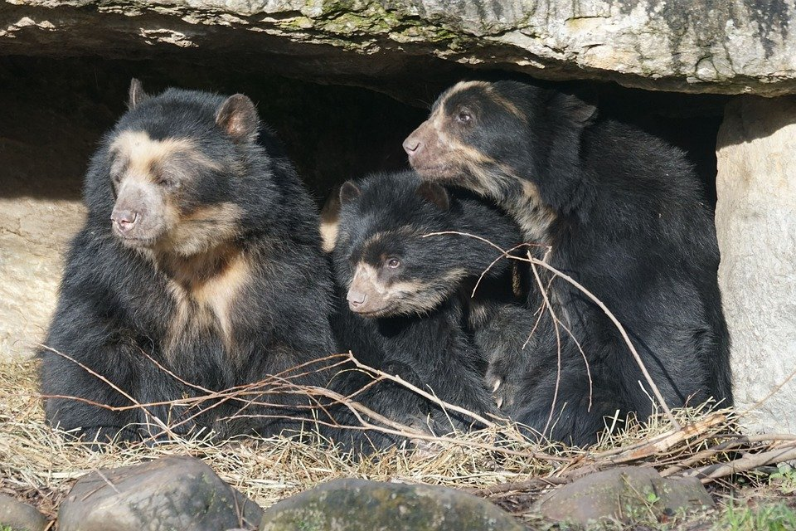

powerful claws

whitish eye rings

secretive

skilful climber

grinding

sweet-toothed

vegetarian

nocturnal

shaggy fur

spectacled bear

**Word Wall**